## **HBF Guidance for Stairwell Working and Exposed Edges Internally**

**Scope of Guidance**

This guidance includes:

1. The installation of stairwell protection
2. Working with sacrificial joists
3. Differentiate between traditional and timber frame working practices
4. Working around exposed openings, proprietary coverings, and sequencing of works.
5. Management of the stairs during the construction phase.

The Objective is to improve working practices as contractors move between HBF member sites.

We also anticipate this more consistent approach will have an additional benefit for the contractors, whereby the quality of risk assessments and method statements will improve due to pre-determined acceptable working practices being established.

**Competencies / Trade Specific Instructions**

All personnel involved in the creation of stairwell openings, constructing the temporary and permanent handrails, and the temporary works should be appropriately competent.

**Site Managers**

Should be trained in how their organisation requires them to undertake inspections and record their findings. Site Managers should be trained in how to manage the process, as per their organisation’s procedures. This may include Permits to Remove or Strike, Permits to Work at Height, or daily inspection registers.

**Scaffolders**

Trainee scaffolders should be supervised at all times, particularly when undertaking propping, prop removal or work at height.

Advanced scaffolders should create the Handover Certificate for the site manager to sign. This includes scaffolding used for propping. The Handover Certificate should be received and signed before operatives commence loading.

All scaffolders should understand the weight loading capacity of the joists in use and avoid point loading in excess of this. Scaffolders must provide a design for a birdcage and ensure their construction matches the design.

All scaffolders should be trained in their safe system of work by their employer.

**Joiners**

Joiners should be trained in how to create a hatch, construct the stairs, erect temporary and permanent handrails, and how to create stud work in the vicinity of the stairs. They should also be trained in any permits to work the Principal Contractor requires them to use and their own safe systems of work.

**Crash Deck Installers**

All crash deck installers must ensure they access the first and additional floors through appropriate access points. They must install the crash deck in accordance with the manufacturer’s recommendations and provide a Handover Certificate when they are satisfied the installation is complete.

**Dry Liners / Boarders / Skimmers**

Safe systems of work should include how the operatives will load out, how they will gain access to the bulkhead and stairs and be trained in how to install and inspect the work at height equipment. They should be trained during induction on any permits to work the Principal Contractor requires.

**Painters**

Safe systems of work should include how the painters will gain access to the bulkhead and stairs and be trained in how to install and inspect the work at height equipment.

**Differentiate between traditional and timber frame working practices**

**Open & Guarded**

This would consist of the stairwell area having an edge protection system installed which would act as a physical barrier to prevent any inward falls into the area where the stairwell will be eventually installed. This could be achieved by using a scaffold tube and fitting system (stuck from the ground floor) or a post and rail system installed on the working floor.

Generally, the stairwell area will be fully barriered off with a self-closing gate and ladder installed. A temporary works design should be sort where an engineer has designed the edge protection to withstand any potential impacts during the construction work. Any installers must install the edge protection to the design provided and should be inspected by a competent person every seven days.

This system would not be appropriate where the stairwell area is next to the party wall. As construction of the party wall would not be possible.

**Sacrificial joists**

These are generally temporary wooden joists installed on hangers around the stairwell area installed at the same time as the main floor and have floor decking installed over. This area is then removed prior to fitting staircases.

Sacrificial joists are to be installed in line with the manufacturers designs and installation guides. Any damaged or missing components should be informed to the site management. They should be designed to a specification that the area is to be used during the construction stage E.g., used as a working platform. The inspection of the sacrificial joist area should form part of the build inspection process prior to being used as a working platform and then inspected periodically when in use.

**Scaffold Decking or Proprietary system**

This approach for fall protection requires a temporary working platform being installed (ideally) flush with the floor. This could be undertaken with the construction of a tube and fitting birdcage/tower or a proprietary safety deck system. The working platform should be designed for its intended use and loading e.g. 2kn working platform. An access point e.g. ladder hatch can be installed to allow a safe access point through during the construction stage.

Once installed this is to be inspected prior to work being authorised in the area and inspected routinely when in use.

**Temporary covers**

There are several fall protection systems on the market that can be installed around the stairwell opening. These range from systems spanning the stairwell area or with temporary joists installed and a platform installed above. They often have removable panels or hatches for access points or allowing materials to be passed through them. Each system will have its own installation manual and loading capacity to be adhered to.

They are designed to be lightweight for handling and ease of use on site whilst providing a large safe standing platform when installed. The system is designed to prevent falls through large stairwell openings whilst giving you full or partial access for operatives and materials.

The temporary covers are also reusable and therefore provide a reduction in waste.

Projects that use proprietary systems must ensure that the installation guide is present and is followed at all times. The system is to be installed, maintained, and removed by competent individuals.

**Access to Upper floors**

**Temporary Access**

During the construction process access must be made available to upper floors. Access during the construction process and prior to permanent staircases being installed this is typically achieved via a form of proprietary hatch and ladder.

These are fitted during the construction of upper floors and are cited within the stairwell location. Refer to Section 3 temporary coverings of stair openings for further details.

Hatches and ladders are classified as items of work equipment and will require regular inspection under PUWER, please refer to section Section 6 - Inspections, documentation, and monitoring for more details.

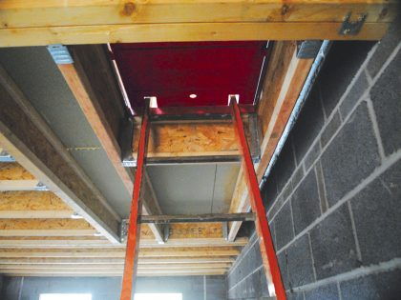

**Staircase**

Permanent staircases will provide the main means of access for operatives undertaking internal works to plots. The installation process will vary depending upon the type of staircase i.e., straight flight or kite-winder and if the plot has multiple storeys. The stairwell temporary cover used (refer section 3) should also be considered when determining access and fall protection requirements.

Safe systems of work for the installation of staircases must assess the risk of fall from an exposed edge and provide suitable and sufficient control measures i.e., temporary handrails and working platforms. Refer to appendices for examples of installation processes.

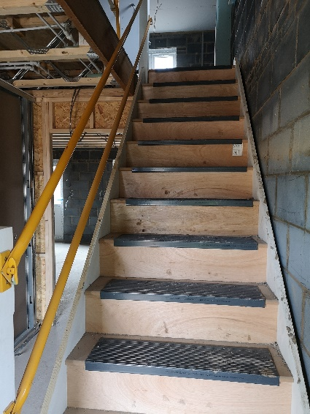

**Temporary Stairwell installation**

In the event permanent staircases are unavailable prior to upper floor access being required alternative temporary measures should be considered. Primarily there are two options

1. Proprietary staircase systems
2. Scaffold tube and fitting staircase

It is essential that the chosen system is suitable and sufficient for the task and is installed by competent operatives in line with manufacturers guidelines.

The use of temporary staircases may be a consideration at this stage, enabling safe access and egress. Temporary staircases may consist of purpose build stairs or tube and fitting scaffold. The use and loading of these must be in line with designs and manufacturers guidelines. Regular inspections will be required, and details added to the temporary works register, refer to section 6 and 7 respectively for more details.

Insert image of scaffold staircase

Opening Protection

1. **Sequence of Works**

Fall prevention and fall protection systems (safety decking systems, bird cage scaffold or soft-landing bags) must be left in place until flooring is installed and stairwells are closed with a suitable covering. This could be sacrificial joists and flooring or a proprietary system.

Once the floor is fully installed the fall prevention/protection system can be removed. For ground floors this is a simple operation of dismantling from below and exiting through front or rear access. For first or second floors equipment should be dismantled and taken down through an access hatch in the stairwell covering.

**Opening stairwells for installation of stairs**

The sequence of works should ensure that any edge protection is fitted before stairwells are opened to ensure that at no point are operatives exposed to an unprotected leading edge.

The following sequence or one similar should be followed:

Before the stairwell is opened, suitable edge protection must be installed around the stairwell to prevent a fall. Normally the carpenters/joiners will gain access through the stairwell floor via a access hatch (following company procedure). A suitable ladder must be used to gain access through the hatch and must be footed and secured at the top to prevent it from slipping. The carpenter/joiner will then gain entry to the floor (first, second or third) and the proprietary stairwell protection can be passed up to him/her to install. This must be done before the remainder of the stairwell covering is removed.

Once the stairwell edge protection has been installed the stairwell can be opened by removing the temporary stairwell cover (from above or below depending on RAMS).

1. **Fixing of Temporary Stairwell Protection**

All temporary stairwell protection regardless of type, whether locally produced out of timber or a proprietary system must be installed securely in line with manufacturer’s instructions or to a design. The structure must be treated as temporary works and fall under a temporary works procedure.

Using the newel post to nail or screw pieces of timber for edge protection is poor practice and should be avoided due to damage and repair costs.

When fitting the proprietary stairwell protection using metal posts (sometimes referred to as Christmas trees), each hole in the footplate must be suitably screwed. The handrails should be approximately 100mm x 50mm CLS (4”X2”) and the timber should be screwed to the metal posts. Service batten must not be used.

The stairwell protection must be stepped back from the stairwell opening approximately 150 - 200mm in order to allow the balustrade on the landing and the bulkhead / stud wall to be installed with the protection still in place. This will ensure that operatives are not exposed to an unprotected leading edge.

**Typical Stairwell Protection**

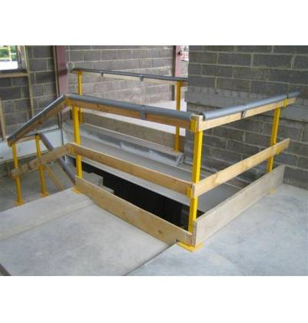

**Typical Stairwell Protection**

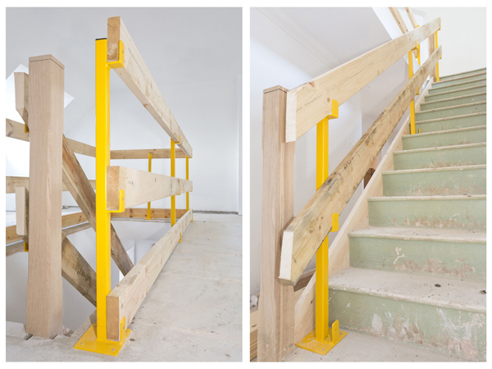

Stairwell protection stepped back to allow balustrade or stud work to be installed

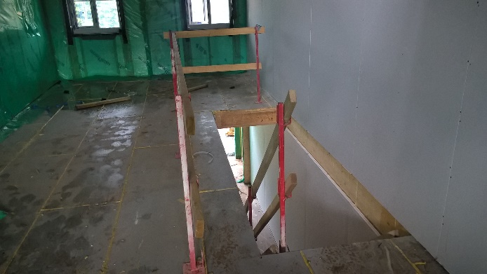

1. **Use of Temporary Stairwell Systems**

The top guard rail must be at least 950mm above the edge from which any person is likely to fall and any intermediate guard rails must be positioned so that any gap between it and other means of protection do not exceed 470mm.

Whatever system is used, the work equipment must not be used until it has been inspected in that position by a competent person and must be inspected again after any event liable to have affected its stability and at intervals not exceeding seven days.

The inspections should be recorded and records kept proving compliance.

1. **Full Height Windows**

Open apertures in the plot at first and second floors for patio doors or full height windows which allow a fall must be protected.

Guard rails and toe boards constructed as above with 100 x 50mm CLS secured to the skin of the plot or to metal posts or proprietary systems set back slightly should be used to prevent falls of individuals and material.

1. **Carpenter sliding stud partition between leading edge and stairwell edge protection**

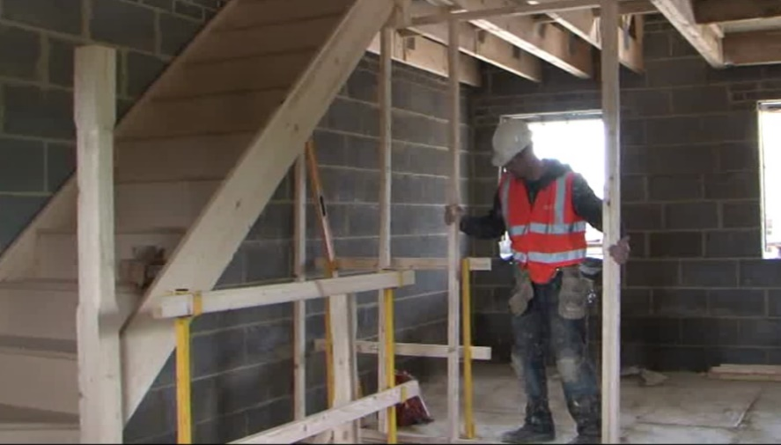

**Stud work in place with temporary edge protection still in place.**

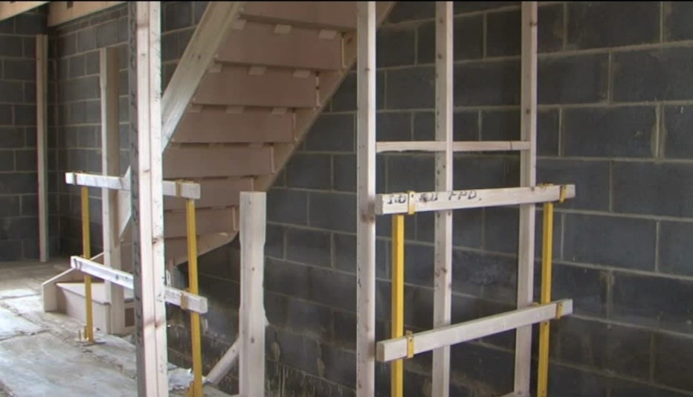

**Inspection, Documentation and Monitoring**

This section of Guidance should be read in conjunction with the HBF document titled “Temporary Works Guidance”.

**Temporary Works Register (Attachment 1 of the HBF Guidance)**

All installations associated with providing a safe working area or access in the area of the properties stairwell, e.g., stanchion edge protection systems, floor cassettes, hatch systems etc are classified as Temporary Works.

Accordingly, all such installations will be recorded within the Temporary Works Register where a series of designations such as Risk Classification, whether a Permit (to use / load) is required, and Design / Design Check requirements are recorded.

**Pre-use Inspection of Temporary Works (Attachment 5 of the HBF Guidance)**

The inspection process prior to first use (or loading) of Temporary Works is clearly identified by the “Risk Classification” assigned to the equipment being used and will provide an indication of whether a permit to use (or load) is required.

In simple terms items allocated a “0”, e.g., some installations of temporary edge protection / stanchions, are low risk and will not generally require a permit to use / load or formal inspection other than a confirmation from the relevant TWS that the items are installed to design.

Conversely items allocated a “2” e.g., stairwell cassettes that are to be loaded with block during the build process, are higher risk and require a more thorough design check / authorisation and will normally require a formal check and confirmation prior to loading.

**In Service Inspection (Attachment 5 of the HBF Guidance)**

Other than the pre-use inspection it will be necessary to carry out and record an inspection of all Temporary Works on a frequency not exceeding one week.

The weekly inspection should be carried out to confirm that the Temporary Works remain safe to use and are installed to design.

The inspection can be carried out by the TWC or TWS depending on the assigned Risk Classification.

**Documentation**

All users’ guides / handbooks or specific designs should be identified and recorded in the Temporary Works Register with copies referenced for use and review as appropriate.

**RISK CLASSIFICATIONS**

Organisations are likely to have their own risk registers or Temporary Works Register which will assess the level of risk associated with the temporary works. Below is an example of such an assessment:

|  |  |  |  |  |  |
| --- | --- | --- | --- | --- | --- |
| **Site Activity** | **REQUIRED** | **RISK** | **DESIGN** | **RESPONSIBILITY** | **NOTES** |
| **SITE SETUP** |  |  |  |  |  |
| HOARDING & GATES | YES | LOW | Fencing Contractor | Site | Daily inspections |
| HERAS | YES | LOW | Heras. Generic | Site | Daily inspections |
| **STAIRWELL WORKING** |  |  |  |  |  |
| OCKWELL SYSTEM | YES | MEDIUM | Ockwell Generic | Joinery | Daily inspections |

**References & Further Reading**

BWF Installation Guide for Timber Stairs

BS5975 – Temporary Works British Standard

Safety Platforms Ltd Edge Protection Guidance

MK Engineering Services Stair Safety System

Work at Height Regulations 2005

INDG401 Work at Height Guidance