Introduction
This guidance has been developed by the Home Builders Federation (HBF) to set out the key requirements of legislation, HSE guidance and insurance standards for managing the risk from fire during the planning and construction stage of a housing development. This document has been set out in the form of a checklist to aid members in assessing their compliance with fire requirements (blue sections). It also includes examples of good practice (green sections) which should be considered for implementation by HBF members.

Scope
The scope of this guidance document is limited to two storey houses of all types including timber frame.

Reference Documents

- JCOP Fire Prevention on Construction Sites – (JCOP)
- HSG 168 Fire Safety in construction
- Structural Timber Association 16 Steps to Fire Safety
- Structural Timber Association – Guidance Documents

Requirements

Pre - Development Phase

Ref | Topic | Assessed  Y/N | Comment /Action
3.1 | Site Selection – Requirements  During the evaluation stage of land an initial fire assessment must be completed to determine:  - If the site is suitability for construction.  - Risk from / to existing properties.  - Construction method e.g., suitable for use of timber frame.
Site Selection – Good practice
- During the evaluation of a site an execution plan should be developed.
- Develop off site fire risk assessment.

Design Phase

Ref | Topic | Compliant Y/N | Comment /Action
3.2 | During the design stage the designer / Principal Designer must:  - Establish a Design Fire Risk Assessment including:  - Assess the risk during the construction and ensure that travel distances can be achieved.  - Assess the risk to end users and ensure that fire control measures are built in.  - Specify approved construction materials.  - For Timber Frame there may be extra requirements to consider at this stage – specialist advice may be required.
Design Good Practice
- A schedule of fire stopping materials should be developed for the project for use by commercial, construction and procurement teams.

Planning and Mobilisation

Ref | Topic | Compliant Y/N | Comment /Action
4.1 | Planning – Requirements  During the planning stage of the project the following needs to be undertaken:  - Project prestart meetings to cover fire risk management.  - A competent person appointed to:  - Complete the Fire Risk Assessment for the construction phase of the project.  - Offsite Fire Risk Assessment.  - Construction Phase Plan to be updated to include fire arrangements  On sites where there is more than one Developer involved, e.g. Consortium sites or where sites are next to each other, fire arrangements for these sites should be documented and shared.
Planning Good Practice

- A training matrix setting out the competence requirements for all personnel with fire management responsibilities must should be developed based upon the guidance issued by the Construction Industry Advisory Committee (CONIAC) and hosted on the Construction Health and Safety Group (CHSG) website. https://www.chsg.co.uk/

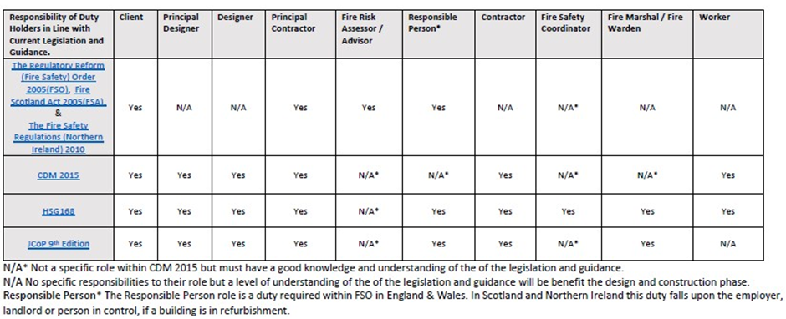

- Individuals undertaking the role of Fire Coordinator and Fire Marshall should be appointed using an appointment letter.
4.2 | Mobilisation – Requirements  During the initial / mobilisation stages of a project the following needs to be undertaken.  - A Fire Risk Assessment and Fire Plan must be developed by a competent person for the initial site set up.  - Firefighting equipment (based on the assessment) to be on site.  - System for raising the alarm to be in place.  - Induction and fire assembly point to be established.  - A competent person(s) is to be appointed as the Fire Coordinator and Fire Marshal.  - Site signage needs to be in place.

Construction Phase
Ref | Topic | Compliant Y/N | Comment /Action
5.1 | Liaison with the emergency services and others  The Site Fire Coordinator is to ensure:  - Early engagement with the fire and rescue services.  - Co-operation and co-ordination with neighbours on the management of fire risks.  - A process is in place to identify any changes (Change Management) form the Design Stage.
Liaison with the emergency services – good practice
- Establish a fire box at the main entrance to the site containing site plans showing key information such as fire hydrants, gas and fuel storage areas. An example plan is shown in Appendix B.
- Ensure, where possible, regular visits by the fire and rescue services take place.

5.2 | Emergency Procedures – Requirements  The Site Fire Safety Coordinator must ensure:  - Based on the RA there must be sufficient competent Fire Marshals/Wardens appointed to cover normal working and leave periods.  - Sufficient water supplies for firefighting.  - Escape routes are in place / maintained.  - Emergency lighting is in place.  - Fire equipment to be provided as per risk assessment.  - Ensure the fire plan is maintained and reviewed at regular intervals or when there are any significant changes.  - Evacuation drills are carried out at regular intervals and recorded.
Emergency Procedure – Good Practice
- Fire wardens/ marshals should be appointed in writing.
5.3 | Temporary Protective coverings  - Temporary protective coverings are to comply with LPS1207 /1215/ Warrington certificate.  - Selection of any temporary protective covering during the construction phase must take into account the relative fire load and the potential for fire growth and spread.  - Any hard boards used as protective coverings must meet Class A2-s1, d0 (BS EN 13501-1) as a minimum.  - As Flame retardant protective coverings can burn, at least one fire escape stairway should be kept free of all protective coverings.
Protective Coverings Good Practice

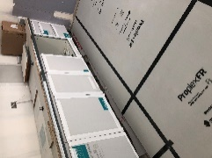
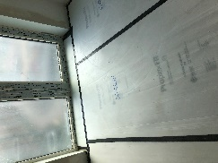

5.4 | Portable Fire extinguishers and alarms for site  - Individuals should be trained in their use.  - Suitable and sufficient extinguisher and alarm types to be provided based on Risk Assessment  - Serviced annually in accordance with BS 5306-3.  - Fire points, which include extinguishers and alarms must be positioned in obvious places in the open or internally in plots, based upon the fire risk assessment. The risk assessment must specifically consider how the sounders/ alarms will be effective in alerting workers to make their escape before a fire becomes life-threatening and extinguishers to tackle incipient fires to prevent them becoming larger, to aid escape.  - Fire points must be raised 500mm above the ground with easily identifiable fire point signage displayed.  - Construction Plant should carry an appropriate fire extinguisher where practical.
Portable Fire extinguishers and alarms Good Practice
- To protect fire extinguishers from adverse weather it is recommended they are placed in a weather proof cabinet, preferably alarmed.
- Consider the use an interconnecting system (wired-in or wireless) of call points and warning devices for a more effective fire warning system.

5.5 | Site Security Against Arson  - Adhere to insurance company requirements.  - Non climbable perimeter fence at least 1.8m high and inspected weekly.  - Combustible waste material is kept to a minimum.  - Site entrance to be secured / monitored.  - Additional security may be required for timber frame sites.  - Review crime database and establish security arrangements accordingly.  - Consider out of hours security audits.
Site Security – Good Practice
If using movement activity CCTV and Fire alarms the alert should go to a control centre which is able to send out a team to respond to the alarm.
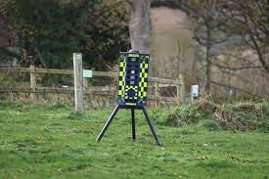

5.6 | Temporary Accommodation units – Requirements  - Position of the TAUs to be 10m away from construction activity, or 6m fire barrier in place or in accordance with specific risk assessment by competent person.  - Occupants – Assess maximum occupancy and vulnerable users.  - Use of the TAUs - clearly defined areas. (e.g., separating cooking / drying areas from storage areas)  - Risk assessment of TAUs must consider travel distance, linked fire detection systems and alarms.  - Materials from which the TAUs are constructed.  - Management of the TAUs - e.g., Electrical testing etc.  - Size, number of storeys (or stacking) and the complexity of the layout of the TAUs
5.7 | Management flammable / hazardous materials  - Avoid the use of flammable / hazardous materials wherever possible.  - Quantity to be kept as a minimum.  - Ensure that the position and the amount of flammable / hazardous material is managed so as not to increase the Fire Risk.  - Signage  - LPG – to be stored in accordance with the JCOP.  - Store flammable liquids in accordance with section of the JCOP.  - Acetylene is recommended not to be used unless specific approval is obtained and controls implemented as per the JCOP.  - Combustible materials to be removed from timber frame at the end of each shift.
 | 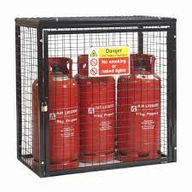
5.8 | Hot Work – Requirements  Ensure any hot work is avoided where possible and any hot work is supported by an activity risk assessment.  The Site Fire Safety Coordinator must ensure that for any hot work (e.g., grinding, cutting rebar, welding, soldering, lead work):  - A hot work permit is issued at the place of work by an authorised person.  - A fire watch is maintained during hot work, breaks and fire watch period.  - Individuals undertaking the fire watch have training in the use of fire extinguishers.  - Two fire extinguishers are provided, one of which must be foam or water with a 13A rating.
Hot Work – Good Practice
- Ideally photographs of the immediate vicinity, adjacent voids and vulnerable spaces should be taken to demonstrate that a fire watch has been undertaken.
- Where there is a risk that heat has been transferred through by pipework, ducting or void a Thermographic camera should be used during and after the work as part of the fire watch.
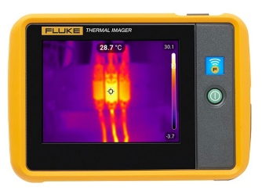

5.9 | Electricity  The Site lead must ensure that Electrical supply installations, both temporary and permanent, are installed in accordance with the latest edition of BS 7671: Requirements for electrical installations and the Electricity at Work Regulations 1989. They must also ensure:  - Electrical equipment is maintained and inspected in accordance with current legislation and guidance.  - Temporary electrical cables which are positioned at height to eliminate a trip hazard must be secured with metal clips or metal sky hooks.  - Where cable drums are used these must be fully uncoiled to reduce the risk of overheating.  - Temporary lights can easily become an ignition source if broken. Use lower-risk lighting where possible, such as LEDs. Lights must be positioned and secured off the ground. If they are mounted on tripods, make sure that the tripod cannot be easily dislodged or overturned. Make sure that lighting equipment and heaters are not inadvertently covered or left bunched together so that it cannot ignite any combustible material nearby, or the structure itself.
5.10 | Tool Charging – requirements  - Site managers must ensure that a dedicated battery charging area is made available for trades to utilise e.g., specific charging point locker.  - These charging areas must be installed and tested by a competent electrician.  - All battery chargers must be Portable Appliance Tested (stickers attached) and chargers and batteries must be branded, genuine products. Counterfeit electrical chargers and batteries can pose a risk of fire and must be avoided.  - The practice of charging tool batteries in site offices or canteens on an ad hoc basis must be avoided.
Battery charging station
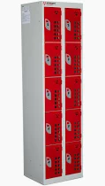

5.11 | Gas safety – requirements  - Gas supply to appliances should be by fixed piping or armoured flexible tubing.  - Gas cylinders should be located outside buildings, secured, and protected from unauthorised interference.  - Gas appliances should be fitted with control taps. (If the only control is on a cylinder situated outside a building, there can be a dangerous build-up of gas during the time lapse between turning on and ignition.)  - LPG connected to an appliance by a flexible link should only be installed by a competent person.
5.12 | Site storage of flammable liquids and LPG  - Stores of liquid fuels must be surrounded by an imperforate bund sufficient to contain the maximum contents of the largest drum stored, plus 10 percent. The bund must not be allowed to accumulate water or waste material.  - Flammable liquids & LPG must not be stored together.  - Where it is necessary to store flammable liquids and gases in circumstances other than as in the previous paragraph, the quantity stored must be the minimum necessary and no more than a day’s supply. The containers must be kept in a store, cupboard or bin which is of fire-resistant construction.  - Storage areas should be sited as far as reasonably practical from permanent and temporary buildings and at a minimum of 20 m wherever possible in the case of high fire risk sites. Where practical, given the constraints of the site, containers and drums of flammable liquid or gas cylinders must not be stored within 10 m of any building or boundary fence (and in no circumstances closer than 4 m) unless the boundary is a wall at least 2 m high and constructed to provide a minimum of 30-minutes fire resistance. In the latter case, containers and drums should be at least 2m below the top of the wall.  - Products which could add to the intensity of a fire, such as acetylene or oxygen, or to the toxic hazard in the event of fire, such as chlorine, must not be stored in the same compound as flammable liquids & LPG.  - Appropriately worded warning signs, e.g., “Highly Flammable Liquid”, “No Smoking” and “No Naked Lights” must be displayed prominently at the entrance to the stores.  - The floors of flammable liquid or LPG cylinder stores should be paved or compacted level, with a suitable hard standing provided for the delivery and dispatch of cylinders. The area must be kept clear of all combustible materials, weeds, and rubbish.  - Any electrical fittings, e.g., lights and switches, within such stores must be suitable for the environment in which they are to be used (i.e., where a flammable or explosive atmosphere may be present) and be selected and installed by competent persons (ref 30).  - The provision of automatic flammable gas detection equipment should be considered for enclosed storage locations.  - Adequate numbers of extinguishers appropriate to the hazard should be sited at entrance to storage areas.  - There should, where possible, be designated areas for fuelling plant & vehicles. The use of petrol generators in high-risk structure should be avoided.
Site storage of flammable liquids and LPG
Containers of flammable liquids and LPG cylinders should preferably be stored in open compounds which are securely fenced, shaded from the sun and remote from pits, drains and low-lying areas.
5.13 | Acetylene  - Acetylene is recommended not to be used unless specific approval is obtained and controls implemented as per the JCOP.
5.14 | Waste Management – Requirements  The Fire Safety Coordinator must ensure:  - Combustible waste is minimized.  - Waste packing, materials, wood shavings, etc. are removed from the workplace at least once a day.  - All non-essential combustible wrapping and packaging should be removed and placed in a safe place away from the working area.  - Separate metal bins, with close-fitting metal lids, must be provided for combustible materials such as oily rags.  - Where practicable, rubbish chutes should be constructed outside the building and be of fire­ resisting construction. They should be situated so as not to obstruct escape routes.  - Unwanted materials from open areas of a site must be collected at regular intervals.  - All recycling collection points and other combustible waste materials awaiting disposal must be kept in an area at least 10m away from the building under construction, temporary buildings, smoking shelters, stores, and equipment.  - All dry vegetation must be cleared regularly.  - The burning of waste material is prohibited.
5.15 | Plant and vehicles – Requirements  - Stationary plant powered by internal combustion engines, such as compressors and generators should be positioned in the open air.  - They must be sited so that exhaust pipes and exhaust gases are kept clear of combustible materials.  - Operating and refuelling (especially with petrol) should be in the open air at ground level.  - Use of portable petrol-fuelled generators indoor must be prohibited.  - Refuelling of vehicles:  - Fuel tanks must not be filled whilst engines are running or hot.  - Vehicles must only be refuelled in designated areas.  - Fuel must be stored in double bunded fuel tanks, at least 10m away from buildings under construction and temporary buildings.  - Fuel tanks must have spill kits (Enviropad) to absorb drips and spills during refuelling.  - A fire point must be sited at each refuelling area, with appropriate fire extinguishers and a fire alarm.
5.16 | Parking  Vehicles are not to be parked within 10m of any building under construction, the only exception to this is when contractors are required to unload or load equipment and materials and for no longer than the duration it takes to unload or load the vehicle
5.17 | Electrical vehicle charging  Electrical vehicle charging stations shall be sited in the open, a minimum of 10m from any building under construction, temporary buildings, combustible material storage areas, and hazardous installations. In circumstances where the required separation distance cannot be achieved the location of charging stations must be subject to a specific risk assessment.
5.18 | Stored materials  - Where materials are stored on site, arrangements should be in place to ensure that the risk from storing them is identified in the Fire Risk Assessment and control measures are put in place to reduce any risk to acceptable levels.  - Where possible, the substitution of combustible materials for non-combustible materials is considered before storing on site.  - Consideration is given to the timing of use of combustible materials when ordering to avoid unnecessary storage.  - Where possible, any combustible materials are stored outside of the building.  - Combustible materials are stored at a suitable distance away from the building to avoid fire spread.  - Where possible, that combustible materials are stored in locked metal containers.  - Any materials that are stored inside the building have controlled access and are isolated from areas of hot work.  - Any materials that are stored inside the building are within range of a suitable fire detection system.  - Any materials that are stored inside the building are within range of suitable firefighting equipment.  - Any materials that are stored inside the building are covered with non-combustible protection, for example, conforming to LPS1207.
5.19 | Smoking and Vaping  - Smoking and vaping must only allowed be allowed in designated smoking areas which have been highlighted on the Site Fire Plan.  - Vaping and smoking areas must be located in different places.  - Smoking shelters must be located at least 20m away from timber frame structures.  - Smoking and vaping are prohibited in site offices, storage areas or welfare facilities.  - Smoking shelters must be provided with suitable metal ash trays and a separate metal waste bin with a fitted metal lid. Sand buckets or similar vessels must be made available to extinguish cigarettes and a fire point located close by.

Training and Competence

Ref | Topic | Compliant Y/N | Comment /Action
6.1 | Training and Competence Requirements– Requirements  Personnel undertaking the roles of:  - Fire Risk Assessor  - Fire Coordinator  - Fire Marshall/ Warden  - Fire Watch  Must have the relevant training, skills, and experience before being appointed to undertake any of the roles. For further information on course availability see the CITB EN Training List and provision for Homebuilders available from the HBF.

Inspections and Maintenance
Ref | Topic | Compliant Y/N | Comment /Action
7.1 | Inspections  The Fire Safety Coordinator shall ensure that inspections of the fire management arrangements are completed, and a record of the inspections maintained. These inspections should include but not be limited to:  - Alarm and detection systems  - Emergency lighting  - Fire Fighting Equipment  - Means of escape  - Signage
Inspection – Good Practice
- Inspections must be recorded at least weekly; an example inspection record is shown in appendix B.
6.2 | Maintenance  The Fire Safety Coordinator for each location is responsible for ensuring that the following maintenance regime is put in place:  Item Function check Service Note  Fire extinguishers N/A Annual  Emergency Lighting Monthly In accordance with manufacturer’s instructions. Batteries to be fully discharged in accordance with manufacturer’s instructions normally every three months  Fire Panels Weekly Annual  Battery powered heat / smoke detectors Weekly 6 monthly Batteries to be replaced annually.  Wired heat / smoke detectors. N/A Annual / in accordance with manufacturer’s instructions.

Review
Ref | Topic | Compliant Y/N | Comment /Action
8.1 | Documentation Review  Fire management documents e.g., Risk Assessments, plans must be reviewed every three months or after significant changes.
8.2 | Fire Arrangements  The inspection and review of fire arrangements e.g., fire points, detection, call points, escape routes must be undertaken weekly.

Appendix A – Example Fire Plan Contents

The fire plan should show the following information:

  - Fire and rescue service access
  - Dedicated emergency escape routes
  - Positions of hydrants on site
  - Service isolation points (e.g. gas and electrical)
  - Fire points
  - Temporary buildings and their intended use (e.g. canteen, office, welfare)
  - Hazardous items

Appendix B – Fire management Documentation examples
