Safety Checks and Maintenance Requirements for Dumpers

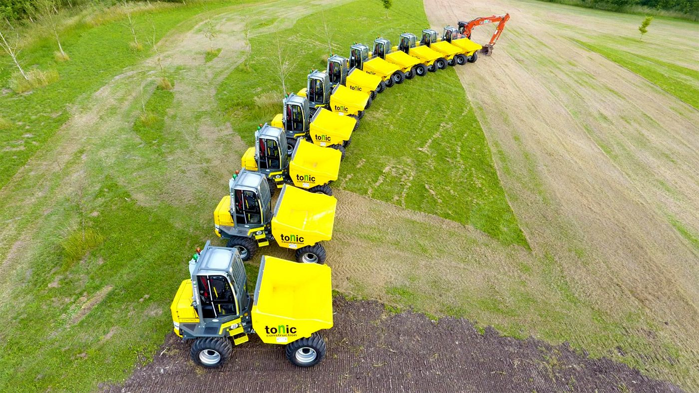

Contents
- Introduction
- Scope
- Safety checks/inspections for dumpers
- Safety checks for a cabbed dumper
- Maintenance requirements
- Actions in the Event of Defects and Breakdowns

1. Introduction
The HBF have created this document to achieve a minimum standard for safety checks/ inspections and maintenance for dumper trucks.
2. Scope
The scope of this document is to provide guidance on safety checks/inspections and maintenance for dumpers. The purpose of an inspection is to identify whether work equipment can be operated, adjusted and maintained safely, with any deterioration detected and remedied before it results in a health and safety risk.
A programme of daily visual checks, weekly formal inspections and servicing schedules should be established in accordance with the manufacturer's instructions and the risks associated with each vehicle.
Any tests for working effectiveness (e.g. brakes) should be robust and repeatable e.g. handbrake – test on a slope of approximately 16 degrees, or 1 in 3.5.
The user is to ensure they have all the equipment and materials to complete the inspection and if required remedial action (e.g. tyres - tyre pressure gauge and compressor and wheel nuts - torque wrench, hydraulic oil – supply of suitable oil etc.).

Drivers should report defects or problems. Reported problems should be put right quickly and the dumper taken out of service if the item is safety critical.
Safety critical definition – e.g. defectives brakes, steering; low tyre pressures, hydraulic leaks, seat belts, flashing beacon, ROPs/FOPs not secure.
Note: This guidance should be read in conjunction with more detailed & specialist guidance contained within the videos:

- 3T Dumper: https://youtu.be/QlnJ9Dbq7P0
- 6/9T Dumper https://youtu.be/aYwidGVu1Uw
- Cabbed Dumper: https://youtu.be/jW5UGBvcLL0

3. Safety checks/inspections for dumpers
PLANT WEEKLY INSPECTION RECORD
MACHINE TYPE |  |  |  |  |  | SITE
MACHINE No |  |  |  |  |  | DRIVER NAME(S)
MACHINE HOURS
Weekly CHECK Date |  |  |  |  |  |  |  |  |  | DEFECTS/  COMMENTS | Date when rectified
Step 1 | Coolant Level
Step 2 | Engine Oil Level
Step 3 | Hydraulic Oil Level
Step 4 | Tyre Pressures |  | Write in actual vs requirement , front and back are different and it varies for machine  Tyre pressure gauge and means of inflating tyres |(compressor) to be on site
Step 5 | Tyre Condition
Step 6 | Wheel Nut Torque by using wheel nut indicators
Step 7 | All Lights
Step 8 | Flashing Beacon(s) Working
Step 9 | Horn & Audible Warning Devices
Step 10 | Mirrors
 | Steering
 | Handbrake – tested on an incline of at least 16%, or 1:3.5
 | Footbrakes tested as emergency stop application
Step 11 | Seat Belt
Step 12 | Access Steps & Handrails
Step 13 | Cab Cleanliness
Step 14 | ROPS & SIPS Condition
Step 15 | Condition of Rams and Hoses, hydraulic leaks
Step 16 | Visual Inspection of Chassis
Additional Comments
DRIVER SIGN & DATE

4. Safety checks for a cabbed dumper
Step 1 | Wiper Blades & Washers
Step 2 | Seat Belt Operation & Condition
Step 3 | Driver Seat and Controls
Step 4 | Door locks and hinges
Step 5 | Operation of Heater/Air Con
Step 6 | Glass Condition
Step 7 | Cab Warning Panel
Step 8 | Cameras (if fitted)

5. Maintenance requirements
In order to minimise the likelihood of lost productivity through break downs.

A scheduled preventative maintenance program helps to meet these requirements. The frequency at which the maintenance activities are carried out must consider the machine usage and the working environment.

A record of maintenance should be kept for each dumper.

Where a dumper is hired out on the basis that the owner is responsible for carrying out maintenance, the owner should inform the hirer, at the start of the hire, that their maintenance staff will require access to the machine at specified intervals.

For owner/hirer responsible items, e.g. greasing, an individual must be assigned to complete the task.

Maintenance records
Comprehensive maintenance records are essential to the safe, efficient and economical operation of a dumper. They provide a complete “cradle to grave” history of the individual dumper giving the following benefits:

- evidence of adequate maintenance as part of the management system;
- establishing breakdown trends over time and providing information for the review of maintenance frequency;
- identification of component failure trends for feedback to the manufacturer;
- evidence of adequate maintenance to the Enforcing Authorities in the event of an incident;
- enabling the performance of the dumper to be reviewed over time to inform future purchases.

Maintenance record format
Maintenance records can be kept in either paper or electronic format. Paper records are often easier to update as the input will often be in paper format such as inspection reports or work sheets. Electronic records are, however, more secure against loss and damage, and the data is more readily analysed. There are many maintenance record software packages on the market, but care should be taken when considering purchase to ensure that the system is flexible enough to accommodate changes in types of input and output.

6. Actions in the event of defects and breakdowns
All defects that make the dumper unsafe for use should be recorded and reported immediately to both the dumper owner and site’s appropriate representative (such as service manager, site manager, or supervisor), and the dumper should be taken out of service. Steps such as removal of the isolator key and ‘locking off’ if possible, should be taken to ensure that the dumper cannot be used before repairs have been completed. All other defects should be recorded and reported as soon as possible.

All defects are to be closed out on the inspection record.

It is essential that repairs or adjustments are only carried out by authorised persons. Once any defects and breakdowns have been rectified, the person carrying out the work should sign the defect report to indicate that rectification has taken place.

Right gauge
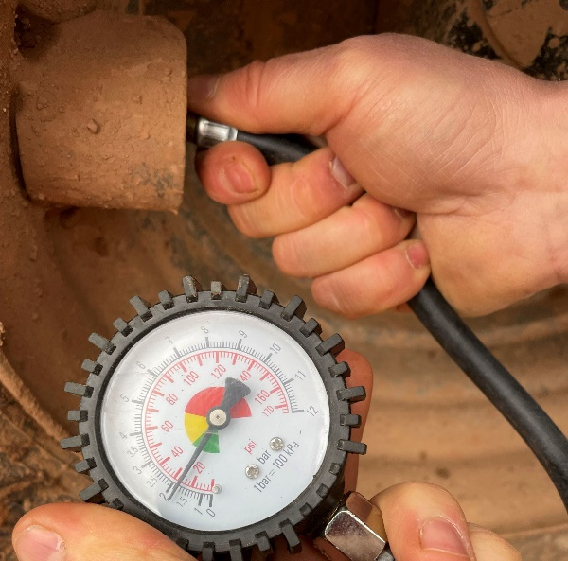

What happens - fully laden dumper, too fast, low tyre inflation:
