

**Home Builders Federation**

**Matter 2**

**Matter 2: Duty to Co-operate**

**Issue 1: Whether the Council has complied with the duty to co-operate in the preparation of the Plan?**

**Duty to Co-operate**

*21. Have all Statements of Common Ground been provided consistent with the requirement of the Framework and the associated Planning Practice Guidance?*

Broadly yes. However, there is limited detail in the Statements of Comon Ground (SoCG) as to when key issues where discussed – in particular unmet needs. PPG states that not every meeting needs to be set out, but HBF would have expected more in the way of detail as to when key cross boundary issues were discussed and how these were then taken into account when considering the quantum of housing to be planned for. As set out in our representations there are significant unmet needs across neighbouring areas and the council will need to provide evidence as to when this matter was discussed with its neighbours given that the SoCGs were only recently published and not, as is required in paragraph 27 of the NPPF, made publicly available over the whole plan making process to ensure transparency.

*22. Has the Council co-operated with the relevant local planning authorities, and appropriate prescribed bodies, in the planning of sustainable development relevant to cross boundary strategic matters? If so, who has the Council engaged with, how, why, and when, with particular reference to the ability to influence plan making and the production of joint evidence and meeting unmet needs?*

This is for the council to answer in detail. The council has clearly engaged with the appropriate prescribed bodies on some issues, namely issue of Water Neutrality, however, there is less evidence with regard to the consideration of collective actions required to address the unmet need for housing. For example, reference is made in the DtC statement and SA to the commissioning of a third Local Strategic Statement (LSS) for the period 2030 to 2050 with the West Sussex and Greater Brighton Strategic Planning Board (WS&GBSPB). HBF welcome the commitment to a third LSS but for information is needed as to when the issue of unmet needs has been discussed at this partnership since the publication of the second LSS in 2016. The WS&GBSPB should be an effective group for discussing unmet needs and securing agreement between authorities on cross boundary issues such as housing needs. However, it is still for the council to show that as a minimum these discussions have taken place, even if it was not possible to agree any outcomes as to a way forward.

*23. Specifically, in relation to Mid Sussex Council, what are the matters of cross boundary strategic significance which require co-operation, and how have these matters been identified?*

This is for the council to answer. However, it is evident that unmet housing needs is a key issue for Mid Sussex and its neighbouring authorities and that there has been a collective failure to properly grapple with this issue at a strategic level.

*24. In considering such matters, including the timing, has the Council co-operated with those identified above, constructively, actively, and on an on-going collaborative basis throughout the preparation of the submission plan?*

More detail is needed as to when specific issues were discussed and between whom. For example, on page 23 of the submitted local plan the council state that officers have met to discuss these, but we could find no detail as to when such meetings took place and how the discussion were fed into the decision-making process. It is also notable that no discussions took place between councillors on the issue of unmet needs with these seemingly all taking place between officers.

*25. I am aware of a number of cross boundary groupings which involve Mid Sussex on a sub-regional level as set out in the various Statements of Common Ground. As a consequence of the Council’s legal duty to co-operate, how has the effectiveness of plan-making activities relating to the identified strategic matters been maximised to enable deliverable, effective policies? In doing so, has joint working on areas of common interest been undertaken for the mutual benefit of Mid Sussex Council and its neighbouring authorities with tangible outputs?*

HBF could find no tangible outcome with regard to unmet housing needs. No testing of a higher figure within the SA to meet more of the unmet needs taking into account significant shortfalls not only in the HMA bit also in neighbouring areas. Not expecting Mid Sussex to meet all these it is clear that these should have been essential considerations in testing what could be delivering in Mid Sussex and the need ot allocated more land for development.

*26. Has Mid Sussex Council been diligent in making every effort to meet cross boundary strategic priorities, including addressing potential unmet development needs arising from neighbouring authorities as referenced in Policy DP5 of the Mid Sussex District Plan 2014-2031 and as requested by neighbouring authorities?*

No. The Council considered 5 spatial options with two of these options, 2 and 3 delivering more homes than the assessed housing needs for Mid Sussex. Option 3 was dismissed in part on the basis that the location considered was considered deliverable. As such this left option 2 as the most appropriate strategy with regard to meeting housing needs. However, it must be noted that whilst option 2 goes above the level of housing need with a surplus no consideration appears to have been given to testing options within the scope of option 2 but which would deliver a higher level of housing growth than is being proposed.

*27. Notwithstanding the Housing Needs Statement of Common Ground (SoCG) (DC4), signed by the Northern West Sussex authorities, what is the rationale for the prioritisation of meeting the unmet needs of the Northern West Sussex HMA over those of the unmet needs of other relevant HMAs?*

For council. However, in seeking to address unmet needs in a sub region that has such significant shortfalls It is appropriate to identify which authorities are expected to benefit from the additional supply in order to a provide clarity as to whose needs are being met.

*28. Are there strategic matters which have not been adequately considered on a cross boundary basis? If so, what are they and how is this the case?*

HBF does not consider the issue of housing needs to have been properly explored by the Council and its partners given the increasing shortfall between what is needed and the expected supply of new homes in future.

*29. Specifically, has the Duty to Co-operate been discharged in a manner consistent with Paragraphs 24- 27 of the Framework?*

No. The Council have engaged with the relevant bodies with regard to the strategic cross boundary matter of unmet housing needs but the nature of the co-operation on this issue presented in the evidence is not the effective approach that paragraph 26 of the NPPF say is an integral part of plan preparation. It appears that the only outcome of the co-operation on this matter was a recognition of the issue but without any attempt to examine options for increasing supply in order address some of the identified unmet needs either in the HMA or elsewhere.

**Matter 3: Vision, Objectives and Spatial Strategy**

**Issue 1: Whether the Spatial Vision and Objectives for Mid Sussex Council are justified, effective, consistent with national policy and positively prepared?**

*30. Does the Spatial Vision for the 2018 District Plan remain relevant?*

No comment

*31. Are the Plan objectives which have been identified relevant; justified; and consistent with National Policy?*

No comment

*32. Is the Plan period justified, effective and consistent with national policy in particular paragraph 22 of the Framework? Should it be extended, if so, why?*

The plan period is not consistent with paragraph national policy and a departure is unjustified. HBF consider it necessary to extend the plan period to ensure that the council are planning for the number of homes it is required to deliver across what the government consider to be the most appropriate length of time the Government consider to be necessary for effective strategic planning.

**Matter 6: Housing**

**Issue 1: Whether the Council’s approach to calculating its full, objectively assessed needs and housing requirement is justified, based on up-to-date and reliable evidence, effective, positively prepared, and consistent with national policy?**

***Objectively Assessed Need-Housing***

*57. Does the Plan period cover an appropriate time frame for the provision of housing (2021-2039) consistent with national policy? If not, what would be the implications for housing need?*

No. The NPPF states at paragraph 22 that local plans must look ahead for at least 15 years and if the plan were to be found sound it will not be adopted until the summer of 2025 at the earliest. This would result in the plan looking ahead for less than 14 years. The plan period should therefore be extended to ensure the plan looks ahead for the 15 full years required by national policy.

*58. To determine the minimum number of homes required, housing policies should be informed by the Government’s local housing need methodology. As such, are the inputs used to determine the level of housing needed within the Plan appropriate?*

At the point in time that the regulation 19 consultation was undertaken the inputs used to determine the local housing needs assessment were appropriate. However, HBF are aware that the latest affordability ratios were published in March and that for Mid Sussex they reduced from 12.95 to 12.09. This result in a reduction the housing needs assessment from 1,090 dpa to 1,041 dpa.

*59. Are there exceptional circumstances to suggest that an alternative approach be taken? If so, what are they, and how would they impact on housing need? Is the Strategic Housing Market Assessment 2021 (H1) up to date and justified?*

There are no exceptional circumstances to support an alternative assessment of housing need.

*60. What are the implications, if any, of the Gatwick Airport’s proposed extension and DCO on the demand for housing? Does the OAN set out within the submission Plan of 19,620 remain appropriate?*

No comment.

**Affordable housing**

*61. Is the figure of 470 affordable homes per annum set out in the SHMA (H1), split between rented and owned homes, subject to S106 control, based on appropriate evidence?*

No comment

**Housing Requirement**

*67. Is a minimum housing requirement of 19,620 justified and consistent with national policy? What is the status of the 996 dwellings referenced within the table in Policy DPH1 as total under/over supply for resilience and unmet need? Should this figure be included within the annual housing requirement for the district?*

HBF is not clear as to the status of the 996 dwellings referred to by the council. This appears to be both a buffer in supply to ensure that the plan is deliverable over the plan period as well as meeting some of the unmet need arising in neighbouring areas. HBF does not consider it possible for this to be both. If it is to address unmet needs, then this forms part of the Council’s housing requirement against which deliver will be assessed – as was the case in the Hart Local Plan were the unmet needs expected to arising Surrey Heath were included within the Housing requirement of 423 dpa[1].

If it is not meeting any needs of neighbouring areas, then this should be explicitly stated by the council. This gives clarity that the buffer is there to offset any uncertainty arising within its own supply and therefore cannot guarantee the delivery of these homes in order to address unmet needs elsewhere. In considering whether this is to address unmet needs or a buffer in supply it worth noting that based on the amended housing trajectory in topic paper H4 the difference between the requirement in the submitted plan and supply is now 691 and that the council has not included the 996 as a means of assisting neighbouring areas but rather it is a buffer to ensure housing needs are met in full.

*68. Are there other considerations that are likely to drive an increase in the homes needed locally, such as any needs that cannot be met within neighbouring areas namely the 30,000 dwellings of unmet need identified up to 2050 in the Coastal West Sussex and Greater Brighton authorities, Housing Need and Requirement Topic Paper (HNRTP) (H5), and the more immediate housing needs of Crawley, Brighton and Horsham?*

The shortfall in housing in this sub region is substantial and places significant pressure on the housing market in this area. The lack of housing being built in LPAs such as Brighton will inevitably put pressure on the market in Mid Sussex with more people looking to meet their housing needs elsewhere.

*69. If so, are there any policies within the Framework that protect areas or assets of particular importance that provide a strong reason for restricting the overall scale, type or distribution of housing, within the plan area; or would any adverse impacts of meeting the Council’s OAN and the unmet needs of others significantly and demonstrably outweigh the benefits when assessed against the policies of the Framework as a whole?*

There are assets of particular importance as referred to in footnote 7 to paragraph 11 of the NPPF that need to be considered as part of plan preparation. But these do not extend across the entirety of Mid Sussex and as such there are potential sites that could come forward to reduce the shortfall in housing that is arising elsewhere. The Council must look to maximise delivery and allocate further sites in this plan.

*70. Is the requirement for Older Person’s Housing and Specialist Accommodation (DPH4); DPH5: Gypsies, Travellers and Travelling Showpeople and DPH6: Self and Custom Build Housing justified and positively prepared?*

No comment.

*71. What is the housing requirement for each designated neighbourhood area?*

No comment.

*72. Are any main modifications necessary for soundness, if so, why?*

Main modifications are required to clarify the council’s position with regard to unmet housing needs. HBF would also suggest that further site must be allocated in order to address some of the unmet needs ideated elsewhere in the HMA and sub region.

HBF would also recommend that the plan also likely to require modification to set out an immediate review of the plan to take account of proposed changes to the NPPF that are currently being consulted on. While these changes are still out for consultation should the remain as currently presented consideration will need to be given to paragraph 227 which states:

*“Where paragraph 226 c) applies, local plans that reach adoption with an annual housing requirement that is more than 200 dwellings lower than the relevant published Local Housing Need figure will be expected to commence plan-making in the new plan-making system at the earliest opportunity to address the shortfall in housing need.”*

The proposed standard method would see Mid Sussex’s housing needs, across the whole of the Borough, increase from 1090 dpa to 1276 dpa and will require the council to prepare a new plan immediately. However, it is the HBF’s experience that without an incentive to review a recently adopted plan these are rarely undertaken rapidly. Therefore, a strong review policy is required that set out clear dates as to when a new plan will be submitted, and the consequences should that plan not come forward in the agreed timescale. HBF would recommend a policy is included in SS1 along the lines of that adopted in the Bedford Local plan 2030 (reproduced in appendix A). This policy was included in the Bedford Local Plan in similar circumstances when the NPPF was amended in 2018 requiring the use of the Standard Method to assess housing needs.

Mark Behrendt MRTPI

Planning Manager – Local Plans SE and E

**Appendix 1: Review Policy from Bedford Local Plan 2030.**

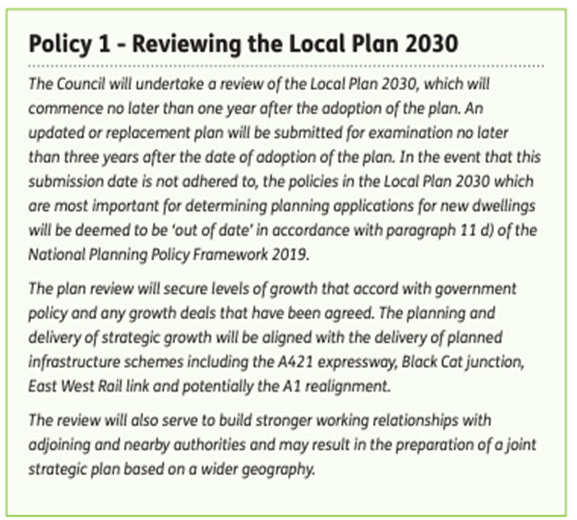

1. Policy SD1 - Hart Local Plan (Strategy and Sites) 2032.