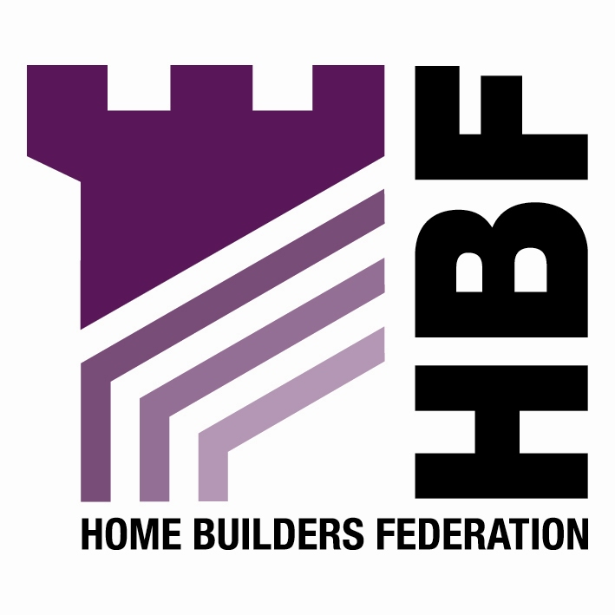


Monday 23 May 2005
Immediate Release

New awards set to showcase the very best in house building

HBF announces shortlist for inaugural Housebuilding Innovation Awards

The Home Builders Federation (HBF) has announced the shortlist for the first ever Housebuilding Innovation Awards. The awards scheme has been devised to recognise and reward the very best examples of house building, with the aim of promoting best practice and quality within the industry. The awards will be presented at the Savoy Hotel on 7 September 2005.
The launch of the awards underlines the HBF’s commitment to driving forward quality in new home delivery. The categories have been designed to reflect the key issues being tackled now by the industry and the Government, and will showcase the moves made to embrace change, improve standards and deliver high quality homes.

The ten categories are: The Environmental Award, incorporating Greenleaf; Best Innovation in the Use of Materials and Products; Best Customer Satisfaction Initiative; Best Example of a Partnership between a House Builder and a Commercial Developer; Best Training/Staff Initiative; Best Partnership with a Supplier; Best House Builder/Public Sector Partnership; Best Example of Community Consultation; Most Innovative Use or Application of Technology; and Best Design Initiative/Partnership with an Architect.
Rob Ashmead, Chief Executive of the HBF commented:
“The Housebuilding Innovation Awards are truly the industry’s own awards, and are unique among the plethora of awards schemes within the house building industry because of their focus on the issues being faced right now. The awards recognise the great work being done within the industry to improve standards, and look set to become a major event in the house building calendar.”
Ends

For more information please contact Katie Thompson at Portland on 020 7421 6120 or katie.thompson@portlandpr.co.uk

Notes to editors

About the HBF

The Home Builders Federation (HBF) is the principal trade federation for private sector house builders and voice of the house building industry in England and Wales. The HBF’s 300 member firms account for over 80% of all new houses built in England and Wales in any one year, and include companies of all sizes, ranging from multi-national, household names through regionally based businesses to small local companies. www.hbf.co.uk

About the Housing Innovation Awards

The Housebuilding Innovation Awards have been jointly launched by the HBF and Housebuilder. For more information http://www.house-builder.co.uk/contents/hbinov.htm

Housebuilding Innovation Awards Shortlist

1. The Environmental Award, incorporating Greenleaf
Allison Homes Eastern - Elsea Park, Lincolnshire
Barratt Homes, Southampton Division - Park View, The Polygon, Southampton
Crosby Homes Special Projects (NW) - greenquarter, Manchester

2. Best Innovation in the use of Materials and Products
Barratt Developments - Terrapin “Advance Housing”
Earthdome – thermal mass housing
Lovell Partnerships - Beswick, East Manchester

3. Best Customer Satisfaction Initiative
Berkeley Homes Oxford & Chiltern
David Wilson Homes
Haslam Homes
Miller Homes

4. Best Example of a Partnership between a House Builder and a Commercial Developer
Barratt Leeds/ Rushbond – Brewery Wharf, Leeds
Barratt West London/Thornfield – Axiom, Feltham, Middlesex

5. Best Training/Staff Initiative
Haslam Homes
Persimmon Homes
St George

6. Best Partnership with a Supplier
Haslam Homes/Wolseley – Supply Chain
Jones Homes/Tensar/Tully De’Ath – St Leonard’s, Sussex
Urban Splash/Yorkon – Moho, Manchester

7. Best House Builder/Public Sector Partnership
Barratt West London - Visage, Swiss Cottage, London
Berkeley Homes - Royal Arsenal, London
Countryside Properties - Chatham Maritime, Kent
Yuill Homes – Queensbury, North Tyneside

8. Best Example of Community Consultation
Berkeley Homes – Royal Arsenal, London
George Wimpey East Midlands - Mawsley Village, Northamptonshire
Gleeson Regeneration – Welsh Streets, Liverpool
Haslam Homes – Grimethorpe, nr Barnsley

9. Most Innovative Use or Application of Technology
David Wilson Homes - Safety System
Miller Homes - Web and text

10. Best Design Initiative/Partnership with an Architect
Crosby Homes/Leach Rhodes Walker – greenquarter, Manchester
David Wilson Homes/ Design for Homes (PCKO) – The Escape Project
Stamford Homes/ LKR Design Group– Michaelgate, Lincoln
Stewart Milne/Malcolm Fraser architects – Maryfield, Bo’ness, East Scotland

