Our ref: RF/SK/HBF/122

5th March 2004

OFWAT
Centre City Tower
7 Hill Street
Birmingham
B5 4UA

For the attention of Pauline Amor

Dear Pauline

Re: HBF’s Response to the Consultation on the Process for Handling Disputes and Appeals

Further to OFWAT’s letter of 11th December 2003 please find enclosed our response to the above document. Our comments have been compiled from views we have received from our Members and following the National Technical Meeting on 25th February 2004.

HBF welcomes the proposals in this Consultation so long as penalties exist. We see the Guidance for the Consultation on the Final Arrangements for Self-Lay and Requisitioning Agreements as important to enable the resolution of disputes to be handled correctly. If the Guidance for the other Consultation is in any way ambiguous and unclear we are of the view that this will be exploited by the Water Companies.

In our response we have stated that the dispute procedure needs extending to Section 104 Sewers and ask that OFWAT gives Guidance on the resolution of retrospective disputes.

Continued………../2

To conclude HBF would like to thank OFWAT for the proactive approach they have taken. These proposals are welcomed and go a long way to addressing the imbalance that has existed since 1989. We also therefore look forward to supporting OFWAT in the future.

Yours sincerely
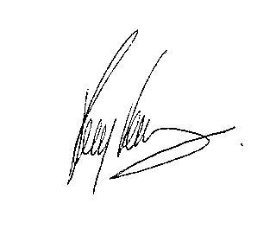
Ray Farrow

c.c. D. Baker – HBF
S. Lewis – HBF
T. Smith - OFWAT

