THE HOUSE BUILDERS FEDERATION

P Martin
ODPM
Planning Policies Division (B)
Zone 4/J4
Eland House
Bressenden Place
London. SW1E 5DU

19th December 2003

Dear Sir

REFORMING AND IMPROVING PLANNING OBLIGATIONS

Thank you for consulting the House Builders Federation on the above proposals. I am also grateful for the time that ODPM staff have spent briefing HBF members and outlining the proposals.

The HBF supports the need for a system for planning obligations that is simple, certain, fast and, perhaps most importantly, a system that will deliver the infrastructure needed as a direct impact of the development itself.

We also support (subject to some detailed comment) all but one of the 8 policy changes proposed by the consultation paper. All 7 of these would appear to achieve the government’s objective of making the existing system clearer and faster and could be implemented almost immediately without the need to introduce a planning charge, whether optional or obligatory.

The introduction of a planning charge or tariff could, in theory, present a fast and certain alternative for developers to protracted negotiations. However, there are a number of concerns that must be comprehensively addressed before such a charge is introduced. These are set out in detail in our response but may be summarised as:

- The detailed rules of how a charge will be set and implemented;
- The limits of what can and cannot be included within the charge;
- How the ability to negotiate will continue if the link between the development proposal and the planning obligation is broken (the abandonment of the necessity test)

This third point is critical in local authority areas that have both high and low land value. If much needed regeneration is to take place the charge must be able to respond to areas of low land value.

You will appreciate that the HBF is anxious to learn how our concerns about the problems of establishing a planning charge are to be addressed, given that these were first raised by us in our previous discussions over a potential tariff system some 18 months ago. Certainly, there is much more to discuss regarding these particular proposals before we can take comfort that it will achieve our shared objectives in this area.

We look forward to continuing the debate regarding this issue over the coming months and hope that the government is prepared to listen to respondees in order to achieve a practical and equitable solution for all users of the planning obligations process.

Yours faithfully
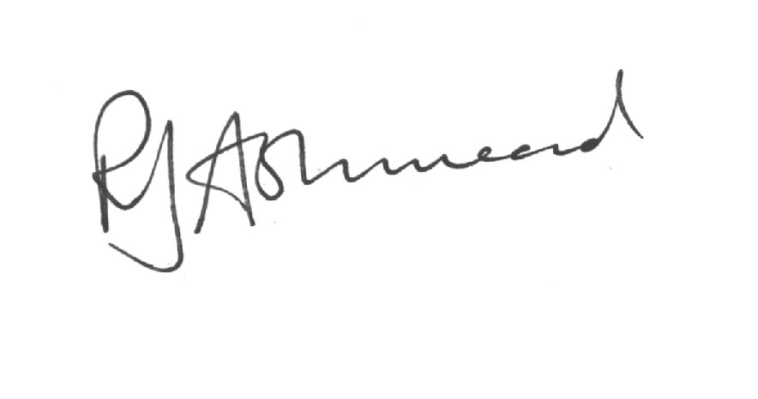
Rob Ashmead

Chief Executive

