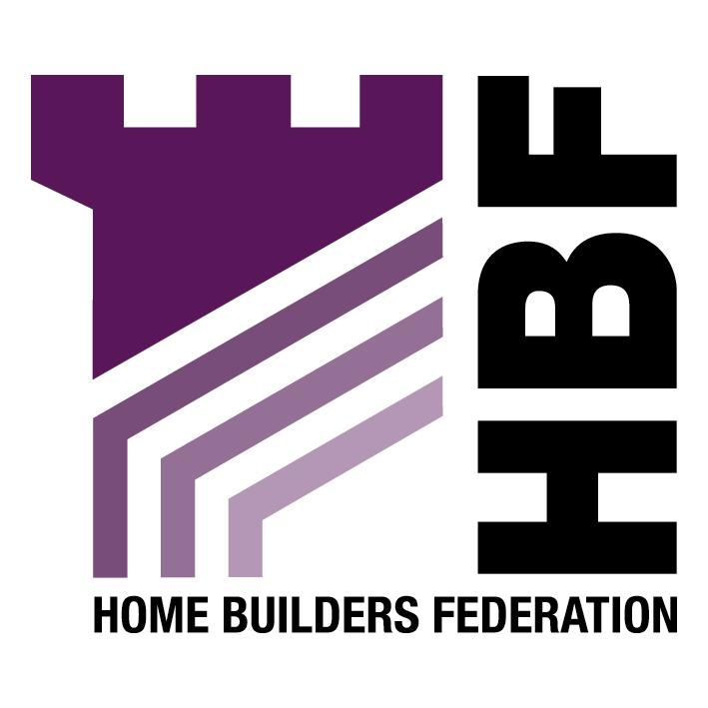
HBF Wales Dinner
The St David’s Hotel & Spa, Cardiff

Friday 25 November 2005

Tickets
£85 inc VAT

Black Tie

7.30 for 8pm

3 Course Dinner with Wine

Charity Raffle
Comedian – John Ryan

_______________________________________________________________________________

HBF WALES DINNER 2005

No. of attendees (tables of 8-10 can be booked)

Cost per person £85 inc VAT. Total Cost

Contact Name _________________________________________________________________________

Company Name _______________________________________________________________________

Company Address _____________________________________________________________________

Tel ______________________ Fax _______________________ Email ___________________________

Special Dietary Requirements ____________________________________________________________

We would like to donate _____________________________________ as a raffle prize for the charity raffle.

Cheques to be made payable to HBF
Please complete and return with full payment asap to:

HBF Events
Home Builders Federation
1st Floor
Byron House
7-9 St James’s Street
London
SW1A 1DW

Tel: 020 7960 1646
Fax: 020 7960 1601
Email: events@hbf.co.uk

Note: 21 days notice of cancellation must be given

A VAT receipt will be issued within 14 days after the event VAT Registration No: 564579987

