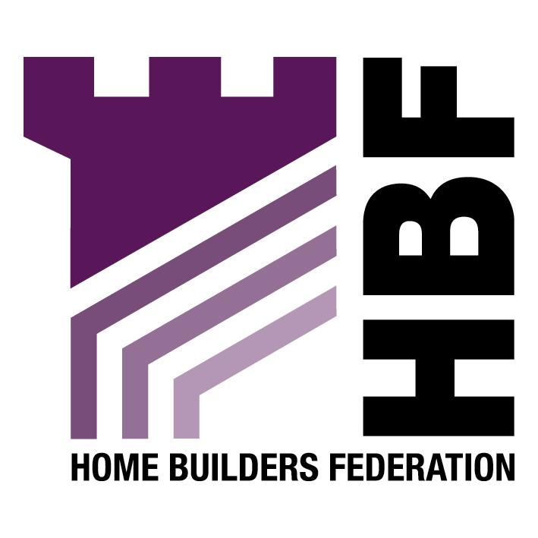

THE HOME BUILDERS FEDERATION

PLANNING FEES

OVERVIEW

The Welsh Assembly Government is currently consulting on plans to increase planning fees from April next year. Basically they are proposing a fee increase of 32% across the board over a 2-year period. This would raise the cost for outline planning from 240 per 0.1 ha to 276 in 2006 and 317 in 2007. The other main issue for house builders is the removal of maximum fees. Comments are sought by 5 September. The consultation document can be viewed at: www.countryside.wales.go.uk/consultations .

BACKGROUND

Research carried out for the Assembly by ARUP indicates that a fee increase between 43% and 75% is required if fees are to meet the costs of providing the development control service (the variation between 43% and 75% is based on if legal, administration and office costs are included or not). The key findings of the research include the following:-

- Need for costs to be reviewed annually to take account of average inflation in the previous year.
- Need to ensure that fee income is related to the costs and provision of the planning service
- Need to change the system of maximum fees to ensure a more efficient, equitable and practical system of fee charging can be devised
- There is a sound basis for charging for more for minerals and waste developments (major developments)
- The approach has been to assume that public funding should provide public goods, while private services should be funded by user charges
- There is a sound basis for an increase in fees charged

Increase in fees

The proposal is for an across the board increase in all fees categories over a one/two year period. However the increases will be proportionately higher for major applications as they intend to either raise the maximum, or to remove maximum fees and thresholds levels altogether.

The Welsh Assembly Government is consulting on five options but the preferred option is Option 2.

Dwellings (outline per 0.1 ha and full per dwelling)
 |  | Current | April 2006 | April 2007
Option 1 | 44% over 2 years | 240 | 288 | 345
Option 2 | 32% over 2 years | 240 | 276 | 317
Option 3 | 27% over 2 years | 240 | 276 | 303
Option 4 | 21% over 2 years | 240 | 264 | 290
Option 5 | 43% over 1 year | 2400 | 343

Maximum Fees

Views are requested on whether or not to remove the fee ‘cap’ or to raise the ‘cap’ to ensure that costs are covered. Members should note that in all of the above options the removal of the fee cap for residential is proposed.

OTHER CHANGES

A simplified structure for fees combining a number of categories:

- Buildings (other than dwellings, agricultural buildings, plant or glasshouses etc) where no floor areas is created or is under 40 sq m.
- Advertisements on business premises or other land within the business curtilage relating to nature of business, goods sold, services provided, or name of persons undertaking business / Advertisements for the purpose of directing members of the public to – that site
- In planning categories 1,2 ,4, 5, 6, 12, 13 and 15 the detail of the category has been refined to take into account the size of development within Wales.

Raise fees for installing Telecommunications Masts

Possible extension of Fee coverage:
- Removal of Crown Exemption
- Listed Buildings and Conservation Areas
- Article 4 direction
- Tree related applications and notifications

Reducing fees for E-Planning applications (not considered practical at this point)

PERFORMANCE

The Welsh Assembly Government will only introduce further increases on the basis that planning performance continues to improve. They consider that users need to be confident that in bearing more of the costs of the service, they are also receiving a better quality service. It is planned to measure the quality of the service from the following indicators:-
- Customer satisfaction surveys
- PdW Self Assessment returns
- Planning development control returns
- Annual financial data
- Wales Programme for improvement Performance Indicators
- LPA Business Plan
- LPA Annual Spending Plans
- Annual review of Members Briefing Programmes
- Annual progress report of the Assembly Government / WLGA Planning Agreement
- Annual Monitoring reports
- Development Plan progress
- Baseline Spending
- Action plan for realising efficiency gains

Our views on appropriate measure are sought.

POSSIBLE FUTURE CHANGES (2008 ONWARDS)

- Further increases on major applications – differentially
- Pre-application discussion and advice - charging
- Monitoring and compliance on planning conditions – charging minerals and landfill
- Free- go – possibility of removal or charging reduced fee
- Charges for impact assessments

CONCLUSION

It is important that HBF and member companies fully consider the implications of the fee increases and proposals. The issue will be discussed at tomorrows Wales Planning meeting but for those unable to attend please feel free to contact me with your concerns. The HBF will prepare a full response on behalf of the industry. This will be circulated mid August to give plenty of time for members to comment.

Lynda Healy
Planning and Policy Advisor - Wales
14 June 2005

