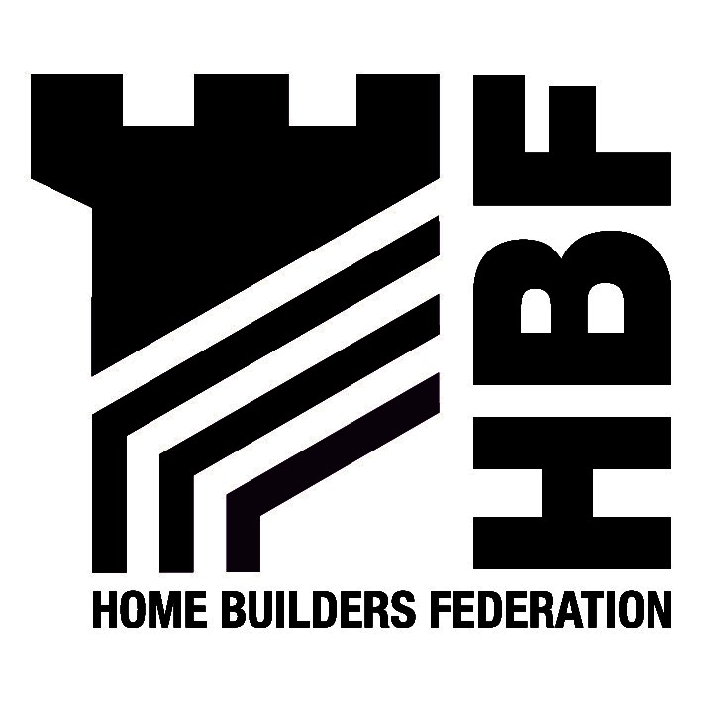

Mr C Logue Response by email
Bury Metropolitan Borough Council
Planning & Economic Development Division
Craig House
5 Bank Street
Bury
BL9 0DN 18TH November 2005

Dear Mr Logue

Draft Development Control Policy Guidance Note 7 – Managing the Supply of Housing Land in Bury

Thank you for inviting the Home Builders Federation (HBF) to comment on the draft SPG. Having read the guidance note we make the following objections and comments.

Use of SPG as ‘Restraint Policy’
The HBF object to this SPG as technically this suggested guidance note is not supplementary to an existing adopted Local Plan policy. Therefore, no weight should be attached to it when determining planning applications.

PPS3
Given the long awaited consultation draft PPS3 is to be published within the next few weeks, we consider the timing of this SPG to be unfortunate as the revisions to PPG3 are likely to include the recent ODPM ‘Planning for Housing Provision’ June 2005 Consultation paper.

This paper sets out a new policy context for the delivery of the appropriate amount of new housing, planning for a 15 year time horizon through allocating the most sustainable and developable land in the short to medium term and identifying broad areas for development in the longer term. This includes a rolling 5-year supply of developable land. It also examined the role of RSS housing numbers and how they are meant to operate as either a ‘floor’ or a ‘ceiling’.

This new policy direction for dealing with housing provision should be borne in mind when drafting the Bury SPG on managing the supply of housing land in Bury.

GONW role and RPG13
In paragraph 2.3 of the SPG, it appears the Council are suggesting the Government Office for the North West (GONW) are forcing local authorities to impose planning restraint in order to focus future investment into neighbouring areas of low demand, in this instance the Manchester Salford Pathfinder.
Telephone: 0113 2727573 Facsimile 0113 2727574
1 Brooklands Court, Tunstall Road, Leeds LS11 5HL
In doing so, Councils are asked to plan monitor and manage the release of planning approvals based upon their target allocations contained within regional planning guidance (RPG13).

Whilst we acknowledge that planning restraint is now common across most local authority areas in the NW, we are aware that the population trends and economic growth forecasts used to construct the housing allocations in RPG13, are now proven to be fundamentally flawed. Not only are we aware of this fact, GONW are aware of this fact, the Regional Assembly are aware of this fact, the Regional Development Agency are aware of this fact, as are the Northern Way Sustainable Communities workstream. Clearly that messenger pigeon has yet to arrive in Bury.

Interim Draft RSS housing provision – October 2005
The Initial Draft NW RSS is now out for consultation.

Many stakeholders, including the HBF, have committed vast amounts of time over the past 18 months in assisting the Regional Assembly to devise a more transparent and evidence based approach to defining the housing requirement in each NW district. The results of that intelligence led work is now available on the NWRA Interim draft RSS website - where we can see that the required net housing provision for Bury is 600 per annum.

Since 2002, house building rates in Bury have been maintained at a steady 570 units per annum. This would suggest the latest draft RSS requirement for the Borough of 600 homes per annum is both reasonable and achievable.

Assuming the draft RSS continues its progress through the Examination in Public with no significant changes to proposed annual housing provision, it would appear that Bury currently has some 3 years worth of planning approvals to be built and just under 2 years worth of supply currently under construction. Beyond that five-year period there appears to be almost no additional land allocations in the Borough.

Northern Way Growth Agenda
The HBF consider this restrictive policy to be contrary to the spirit of the Northern Way, and is borne out of a concern for housing numbers in the RPG13, rather than being realistic and having regard to delivering sustainable growth.

Bury is located within the Northern Way ‘Manchester City Region’, which is intended to be the main focus for development within the region.

Paragraph 5.3 Interim Draft NW RSS states “The City Region contributes nearly half of the regional total of Gross Value Added (GVA) and is likely to have the greatest potential to enhance the economic performance of the North West.” (underlining our emphasis).

To implement a restraint policy at this late stage could seriously stifle the economic growth potential of the Borough.

In recent months the HBF have been monitoring the rate of planning approvals in North West Districts in an attempt to find a link between restraint in popular NW housing markets and any corresponding increase in planning permissions in NW Pathfinder areas. From the most up to date evidence on planning approvals, and from our internal knowledge of key northern developers and house builders, we have in fact witnessed a significant increase in the rate of planning permissions being granted in West Yorkshire to developers who would have normally operated on the western side of the Pennines. In our opinion, current NW restraint is now driving future investment eastwards along the M62. Whilst this may accord with the Northern Way intention of retaining investment in the North, we suspect the NWDA may take a more dim view of this unintended outcome.

Figures 1 and 2 below demonstrate the more recent NW and Yorkshire trends in planning approvals.

Figure 1: Planning approvals in excess of 10 units 2003-2005
Figure 2: Planning Permissions West Yorkshire 2003 and 2005

Brownfield Sites outside Regeneration Areas
Should the Council remain convinced this SPG is sound; we would comment that it was not the intention of RPG13 to restrict the regeneration of brownfield sites. Of particular relevance and support of this argument is an Appeal Decision in Trafford Borough where the Inspector clearly concludes that the purpose of RPG was not intended to restrict the development of brownfield windfall sites in sustainable locations. The Inspector states:

“the wording of RPG policy UR7 is explicit that it is the land identified in development plans (i.e. the allocated sites and not any windfall sites that arise) which is to be monitored and managed…There is no indication that the release of previously developed land in sustainable locations, which arises as windfalls, should be so controlled.”

(Appeal Ref: APP/Q4245/A/04/1144602 – 21 June 2004)

Restricting the development of brownfield sites in sustainable locations subject to ‘exceptional circumstances’ as stated in the ‘Exceptions’ section of the SPG (page 9) is overly restrictive and unnecessary. We object to the principle of restricting housing supply outside regeneration areas inside a Borough located within City Region growth area.

Housing Types.
This SPG demonstrates nothing more than the Council’s ability to count. The purpose of housing delivery is to deliver the right number of the right type of homes to meet the needs of the Borough as required by the Council’s own housing strategy.

We are concerned this purely numbers based approach has no regard to the types of units committed in the Borough that remain to be built - we suspect the majority of outstanding permissions are probably apartments. In our opinion, this old style restraint approach based purely on numbers shows a lack of understating of how housing markets should operate.

Conclusion

Having regard to the above, it is disappointing that Bury have chosen this moment to spend time drafting a numbers based SPG and then hiding behind the GONW at a time when the Council should have been out on the streets undertaking a local market assessment.

We strongly advise the Council scraps this draft policy and seeks further advice on a more intelligence-based approach to housing supply in the Borough. Alternatively, you could adopt this development restraint SPG unchanged and take the Planning Department on a short trip to the M62 where you can then observe lorry loads of NW investment heading eastwards into Yorkshire.

Once again, thank you for consulting the HBF on this SPG, please do not hesitate to contact us should you require further information.

Yours sincerely

Mark Johnson

Mark Johnson
Regional Policy Manager

CC: P Styche, GONW
P White , NWDA

