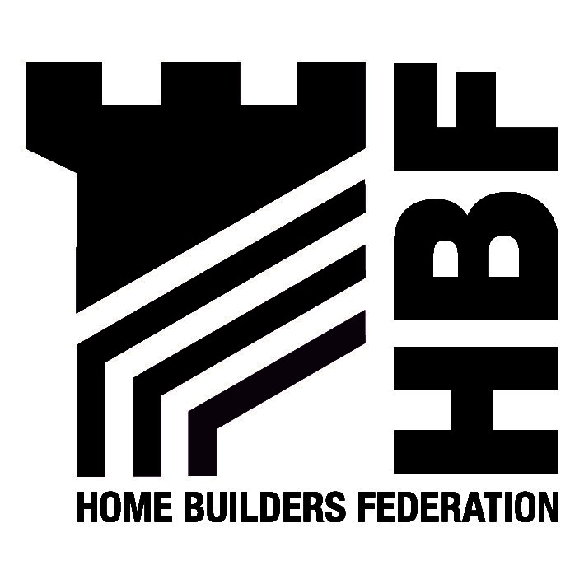

THE HOME BUILDERS FEDERATION

LETTER SENT BY E-MAIL – 30.09.2005 to adrian.smith@env.lancscc.gov.uk

Stuart Wrigley
Director of Strategic Planning and Transport
Lancashire County Council
PO Box 9
Guild House
Cross Street
Preston
PR1 8RD

30th September 2005

Dear Mr Wrigley

Consultation on Draft Planning Obligations Policy Paper.

Thank you for consulting the Home Builders Federation on the draft policy paper. We welcome the opportunity to contribute to the drafting of the Planning Obligations Policy Paper, and having considered the document we have the following comments to make.

With regards to the individual methodology for affordable housing and special needs housing, we do not consider the timing of the consultation draft to be useful, bearing in mind that PPS3 is likely to be released before the end of 2005, which will provide new guidance regarding the provision of affordable housing, and is also likely to supersede Circular 6/98. We therefore believe the timing of this document to be unhelpful, particularly considering that Local Authorities in the County will be guided by the paper for the formation of their individual affordable housing policies.

In terms of the proposed methodology, we would request that paragraph 2.10 is expanded upon to explain what would justify an “exceptional circumstance” in terms of a Local Authority providing “off-site” affordable housing.

Despite the early reference to Circular 6/98 in paragraph 2.1, the Draft Policy Paper is not in accordance with Circular 6/98 with regards to thresholds suggested on page 12 of all sites of over 0.5 ha or greater than 9 houses. Indeed Circular 6/98 recommends at paragraph 10, a threshold of 25 dwellings or 1 ha and lower thresholds of 15 dwellings or 0.5 ha in areas with exceptional local constraints.

Furthermore, the ODPM Planning for mixed communities document, January 2005 recommends a lowering of the threshold to 15 dwellings and 0.5 ha, which again is different to the threshold suggested for Lancashire (although this has not yet been endorsed). Paragraph 11 of Planning for Mixed Communities states: The minimum site-size threshold above which affordable housing is to be sought should not normally be above 15 dwellings or sites of more than 0.5 hectares. There is no explanation in the draft policy document to justify the recommended threshold and no reason why Lancashire should have a lower threshold to that in existing or emerging National policy. The threshold for contributions to be considered towards affordable housing should be justified through the development plan process in all cases. It is important that a suitable threshold for individual local planning authorities is adopted with clear evidence of need or site viability.

There is further confusion in the document, as Appendix 1 (page 44) states a different threshold for affordable housing of 10 dwellings or 0.5 ha to that stated on page 12 of the document. Clarification is therefore required.

Thank you again for giving the HBF the opportunity to comment on the consultation draft planning obligations policy paper. We trust you will take our comments into consideration and look forward to receiving later updates of the document.

Yours sincerely

Gen Berridge

Assistant Regional Planner
Home Builders Federation Northern Regions

