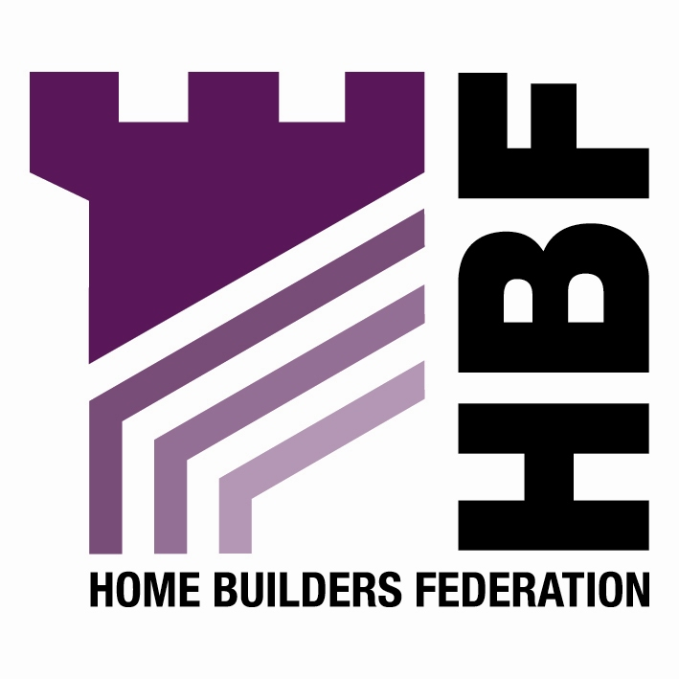
Thursday 23 February – for immediate release

HBF announces new package of measures to drive up skills

Home Builders Federation to outline industry skills strategy at Barker Conference

The Home Builders Federation (HBF) is today announcing a comprehensive industry strategy to increase skills and training within the house building industry. The co-ordinated measures contained in the strategy include:

Seeking fit for purpose skills provision for home building by:
- Assisting in the development of the new Specialised Diploma for Construction and the Built Environment to be introduced in 2008
- Developing comprehensive skills provision for the industry via the Sector Skills Agreement for Construction
- Forging a working relationship with The Academy for Sustainable Communities

Working with CITB-Construction Skills to promote the Major Home Builders Group’s initiatives to:
- Increase the number of training places for skilled trades
- Promote the Construction Skills Certification Scheme through the industry’s sub-contract base with the aim of having a fully carded workforce by the end of 2007
- Develop a new flexible qualifications structure for the management of house building developments

As part of the strategy, HBF will work to extend these Major Home Builders Group initiatives to other members.

The skills strategy will be outlined at the HBF’s Responding to Barker Conference taking place in central London today. The conference is being addressed by Rt Hon David Miliband MP, the Minister of Communities and Local Government. Other speakers will include Kate Barker, Prof Sir Peter Hall and James Paton of HM Treasury.

The strategy has been informed by the findings of a major industry study commissioned from Professor Michael Ball of Reading University for HBF and CITB-ConstructionSkills. The research aimed to provide a better understanding of the future labour and skills requirements needed to meet the increase in supply recommended by Kate Barker.

Stewart Baseley, Executive Chairman of the HBF states, “HBF’s skills strategy highlights the industry’s commitment to addressing skills shortages and providing the skills base needed to achieve a step-change in the rate of housebuilding. These measures will help ensure that new homes are built to the highest standards throughout the industry.”

- Ends -

For media information, or to attend the conference, please contact:

Toby Orr
0207 421 6124
07736 175311
toby.orr@portlandpr.co.uk

Notes for Editors

- The Home Builders Federation (HBF) is the principal trade federation for private sector home builders and voice of the home building industry in England and Wales. The HBF’s 300 member firms account for over 80% of all new homes built in England and Wales in any one year, and include companies of all sizes, ranging from multi-national, household names through regionally based businesses to small local companies: www.hbf.co.uk

- HBF’s Responding to Barker Conference is taking place on Thursday 23 February 2006 at One Birdcage Walk, Westminster, London. Guest Speakers include Rt Hon David Miliband MP, Kate Barker, Professor Sir Peter Hall and Graham Paton of HM Treasury. The conference will examine the Government's response to Barker, especially its proposals for planning reform (draft PPS3) and a Planning-gain Supplement. The HBF will also be announcing the results of HBF's first Customer Satisfaction Survey and its strategy on skills: http://www.hbf.co.uk/index.php?id=742&tx_julleevents_pi1[showUid]=49&cHash=10d91cf48b

- The Major Home Builders Group comprises the eleven largest publicly listed companies.

