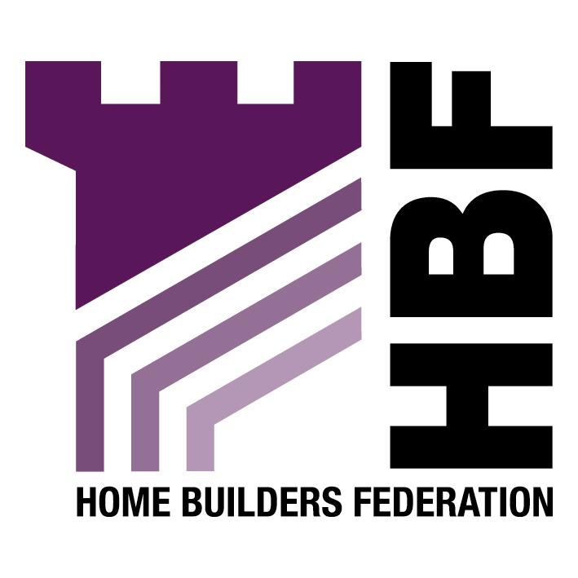

THE HOME BUILDERS FEDERATION

DENBIGHSHIRE LOCAL DEVELOPMENT PLAN

ENVIRONMENT ISSUES
AND OPTIONS

8. OPTIONS

Option 2: Landscape Areas

The HBF is concerned with the use of Local Landscape areas as to a large extent they overlap with green barriers and this leads to confusion. The HBF also has an issue with their purpose which again to a certain extent overlaps with green barriers. The Council should review the use of this policy to determine if it has prevented development would not have been prevented by a different policy. Given the need for more succinct plans the HBF suggests that these designations should be deleted.

Option 3: Sites of Local Conservation Importance

Developers need to know where there are wildlife sites that need to be taken into consideration in planning developments. The HBF would suggest that these need to be reviewed to ensure that they are a true reflection of the current biodiversity situation. The CCW will probably have a view on how relevant the survey work from 1998 is.

Option 5: Green Barriers

Green barriers are not meant to be permanent and therefore Option b would be the correct approach. That is if it can be justified that the social and economic benefits of developing on parts of a Green Barrier will outweigh the environmental issues then there is a case to delete parts of the barrier.

