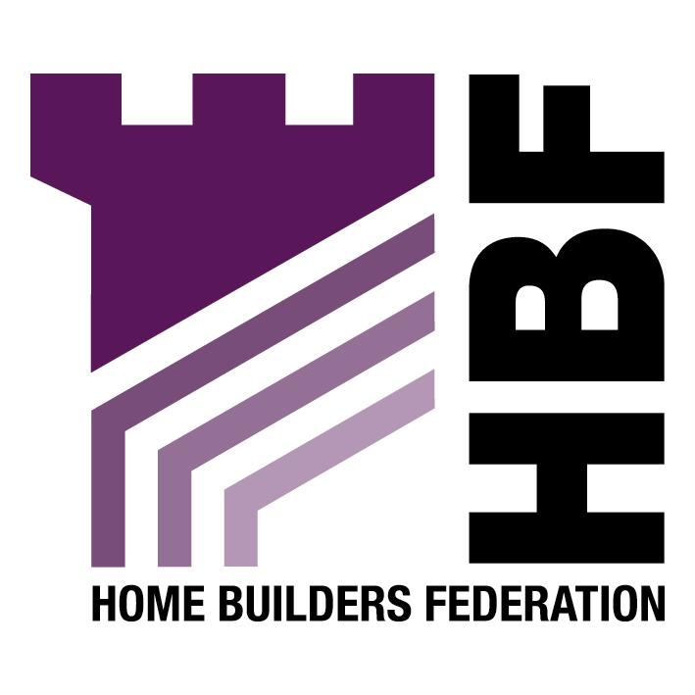

THE HOME BUILDERS FEDERATION
DENBIGHSHIRE LOCAL DEVELOPMENT PLAN
POPULATION & HOUSEHOLD ISSUES
AND
STRATEGIC GROWTH OPTIONS

The HBF is generally pleased with both the content and the strategy being proposed by the Council. The document is generally based on well founded logic and understanding of the issues. The HBF does however have two major areas of concern. Firstly that the council appears to be seeking extremely high percentages of 1 and 2 bed properties and secondly that the approach relies heavily on cross subsidy of housing to enable employment land to be brought forward.

Detailed Comments

1. THE AIM OF THIS PAPER

The HBF is now known as the Home Builders Federation not House.

2. AIMS AND OBJECTIVES OF LOCAL DEVELOPMENT PLAN

The HBF supports the inclusion of the Assembly’s vision for housing, criteria (i), as an aim of the housing chapter.

We question the inclusion of ‘flooding’ as interests of acknowledged importance. The reference should be to ‘flood plains’.

The HBF supports objective (i).

The HBF questions the logic of limiting allocations in rural areas especially those areas that have affordability problems as stated in objective (ii).

The Council will need to take care when expecting residential land to support infrastructure improvements, objective (iii). If the Planning Gain Supplement is introduced along the lines currently suggested then S106 obligations will be scaled right back and there will be no opportunity to claw any cross subsidy from schemes. Even if PGS is not introduced then there will still be a need for the council to be realistic in what they can expect residential schemes to fund and there will be a need to accord with current legislation.

The final objective suggests that the council intends to dictate to the private sector the type, size and affordability of houses. This proposal is totally unacceptable to the HBF as we view the one-person one bedroom approach to meeting housing needs as totally unrealistic. New developments should cater for people’s aspirations rather than a 1-person 1-bed philosophy which is adopted in the social sector. The market is best placed to respond to demand.

5. POPULATION & HOUSEHOLD OPTIONS

The HBF supports the conclusion in paragraph 5.3 that options 2 and 3 are unrealistic due to the Council’s very limited ability to influence in-migration.

Assessment

Assessment Criteria

The HBF supports the assessment criteria but will again raise the issue of the reliance on a cross subsidy on grounds of the introduction of a PGS, the need to conform to guidance and on the need for realistic expectations from landowners.

Future Migration

The HBF supports the Council’s view that reducing completion rates in an attempt to restrict in-migration is not a viable option. The HBF particularly supports the final sentence of paragraph 5.12.

The HBF also supports paragraph 5.15.

The HBF supports paragraph 5.16 as we to agree that these are the best options. We are nevertheless concerned as to how the authority intends to influence the population demographic, as the philosophy of 1 person 1 bedroom does not meet with the aspirations of many people and given that it is the intention to retain these incomers when they have families.

Growth Forecast Conclusions

The HBF also supports the discounting of Option 4 as we agree that it is likely to lead to increasing pressure on the local housing market causing prices to rise further.

Option 1 and 5 appear to be the most realistic options available.

6. AMOUNT AND DISTRIBUTION OF HOUSING LAND

The HBF is uncertain as to what part we can now play in influencing the preferred strategy.

Translating Households into the Housing Requirement

The HBF cannot understand why the Council have taken the average between Option 1 and 5 to provide the 7,700 figure. Is this to give a rough idea of the consequences or is this the approach that will be taken.

The HBF have a number of issues with table 2. Firstly it appears to rely on all allocations and existing commitments being developed, this is unrealistic and was acknowledged to be by the Council earlier in the document.

In terms of the UCS although a discounting rate of 50% appears to be reasonable the HBF reserves the right to comment in detail on the UCS. The normal approach to identifying this supply is through the JHLAS 5-year small sites figure which suggests a contribution of small sites in the order of 861 - that is half that being suggested. Whilst it is accepted that windfalls would be in addition to this figure the HBF is sceptical about achieving the 1600 figure.

It is normal to allow a 10% flexibility allowance to the overall figure to allow for sites not coming forward.

The HBF is again confused by the geographical distribution outlined in the next table, as the HBF understood that the Council intended to influence the geographical spread.

The HBF recognises that rigid growth levels would not be appropriate at this stage and that more work on Housing Market Assessments is required.

Paragraph 6.7 refers to ‘land hording’ however the HBF would suggest that there could be other explanations such as land owners not wishing to sell the land. The willingness to sell should influence the inclusion of sites in Plans. Another reason for landowners not selling tends to be onerous requirements on behalf of local authorities which result in relatively low returns for landowners. Many landowners on signing S106 agreements fail to understand the consequences fully and often will agree to requirements which make the site unviable. Increased planning fees and the reduction in permission periods should deter those who simply hold on to permissions as valuation exercise.

Mixed Use

Although the HBF does not object to a mixed use philosophy providing those uses are compatible we do not necessarily see that the Council will be able to cross subsidise employment land as suggested. The PGS proposal may well have an impact on this proposal. At present it is hard to see how such a policy would meet with Circular 13/97 which requires a demonstrable link between what is being required and the development. In addition to this if this approach became possible through new guidance there is still an issue of how much value is in the land and what would be a fair return for the landowner.

Option 1 – Trend Based Option

There would be strong opposition to a policy that required 97% of new houses to be 1 and 2 bed properties as the industry knows well that this is not what is required. A more flexible approach of achieving mixed and balanced communities would make far better developments. New developments made up of 100% 1 and 2 bed dwellings will result in blocks of apartments which will not enable Denbighshire to create mixed and balanced new communities or to retain the youngsters once they start having families. This is a greater concern given the Council’s aim to utilise a few large sites.

The HBF does not agree with the idea of matching households with house sizes as this is far from what happens in reality, especially in the private sector. Paragraph 6.11 acknowledges this issue, but fails to take it any further. The HBF encloses a copy of its study ‘Room to Move’ which explores this issue further.

There may well be a miss-match of household and dwelling size but as Government policy moves towards Lifetime Home requirements and support the idea that people have the right to remain in their homes this means people being able to live in houses that are larger than they strictly need in terms of bedrooms. The Council need to be aware that large expanses of 1 and 2 bed apartments may not be acceptable to local residents nor the market. The HBF is not saying that there is no place for such developments but that 6,131 1 and 2 bed apartments is unlikely to be what the market seeks, what will retain families, or what will prove acceptable to residents. A more balanced approach is far more likely to achieve the Council’s aims. The council’s problem is in the 20-29 year bracket, the latter of which may well be looking for family accommodation.

7. CONCLUSIONS AND RECOMMENDATIONS

The HBF supports the view set out in the second bullet point.

The HBF agrees that the younger migration profile (option 5) be accepted as the preferred growth scenario for Denbighshire for the period 2006-2021. However, the 20% level of growth is based on a midway point between option 1 and 5 and therefore does not accord with the option 5 scenario. Is the Council suggesting a sixth option?

The HBF does not agree with paragraph 7.3 as the situation is far more complex than the 1 person 1 bed approach being suggested - the aim should be to build mixed and balanced communities. Large developments of 1 and 2 bed apartments will not meet the requirement for mixed and balanced communities.

