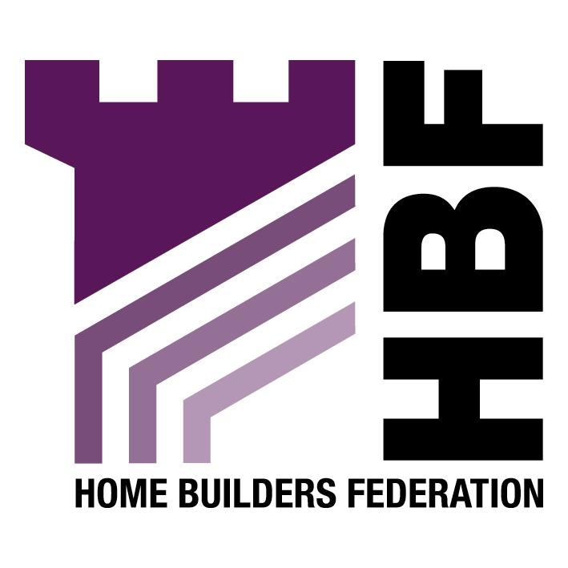

THE HOME BUILDERS FEDERATION

DENBIGHSHIRE LOCAL DEVELOPMENT PLAN
RECREATIONAL STRATEGIC OPEN SPACE ISSUES

3. KEY BACKGROUND DOCUMENTS

TAN (W) 16 ‘Sport & Recreation’

The council should be aware that TAN (W) 16 ‘Sport and Recreation’ is currently being revised and may raise new issues or even set a new approach for the Council.

Denbighshire Open Space Audit Rhyl 2003

In view of the fact that the County wide survey was meant to be completed by 2005 there should be no reason for the Council not taking these findings on board.

4. ISSUES

The County Standard for open space is far higher than the NPFA standard which ranges from 2.2-2.6 hectares. The HBF questions the relevance of this figure and the motives behind it. It could be argued that the Council is using a higher figure to make up for existing deficiencies and therefore it is contrary to Government Policy and could be challenged.

There is also a general questioning of this standard and the approach of having scattered small open spaces that often offers very little recreational use. Most recreation departments favour a more focused delivery of leisure provision and see the NPFA approach as dated. The HBF seeks clarification that the Leisure Services department are signed up to the approach being set in the LDP. It appears unlikely that the approach set in the LDP will help deliver the requirements that will arise from survey work.

5. OPTIONS & ASSESSMENT

The HBF supports the need for a Corporate Recreation and Leisure Strategy as without such a strategy Denbighshire are unlikely to be delivering what is required.

Does the County Standard need revising?

The HBF would argue that it does, as the old NPFA standard does not reflect the way we now live our lives. Walking, cycling, skate boarding and multi use games areas and artificial surfaces that can enable much greater use are far more common than they were when the NPFA standard was devised. Neither does the requirement reflect the fact that children are rarely allowed out to play unsupervised and are far more likely to play in their back gardens. A local needs approach would be far more appropriate.

If the Council proceeds with the NPFA standard approach then they should look to set the County Standard at the correct standard of 2.2 as this is more likely to be an achievable and more realistic standard to meet.

In terms of the recommendations the HBF considers that the authority should reduce the standard. It appears that developers are currently being expected to make up for wider deficiencies by the adoption of this higher standard.

We agree that the current definition of open space needs to be revised as it currently ignores popular recreation land uses.

The HBF agrees that existing open space should be improved but isn’t convinced that current legislation on S106 agreements allows for this or that this would be possible through the Planning Gain Supplement Proposals, which advocates the scaling back of S106 requirements and effectively excludes off site contributions.

We agree that new space should only be set out where it meets an appropriate identified need. A developer should only contribute if there is an identified need as open space provision should not be a tax on development.

Should the 10 dwelling Threshold be reduced?

The answer is no. Unless current guidance on S106 requirements change the HBF cannot see how the authority can introduce a blanket requirement or how it can demonstrate the need for the open space arises out of the development proposal. For example, an OAP complex cannot be required to contribute to a play space, neither can student accommodation be required to provide children’s space. The Council is attempting to tax development which is currently against national policy.

The Council appears to ignore its own responsibilities to the wider community in meeting standards and is using new housing to solve a wider problem that is the council’s responsibility.

The HBF is concerned that the recommended approach will be used against smaller developers who will be forced to buy their permissions. This approach is against current government advice.

Is the Commuted Sum process working where it is not appropriate to provide open space?

Unless policy remains unchanged the SPG will need to be revised. The HBF agrees that the reduction in the threshold level would have resource implications for several Council departments and the HBF suggests that the Council should attempt to evaluate the costs against what it might earn in revenue from such an approach. It may be that more resources are required to process the agreements.

The HBF have no issue with the review of charges but suggests that comparisons are made with appropriate Welsh Local Authorities.

