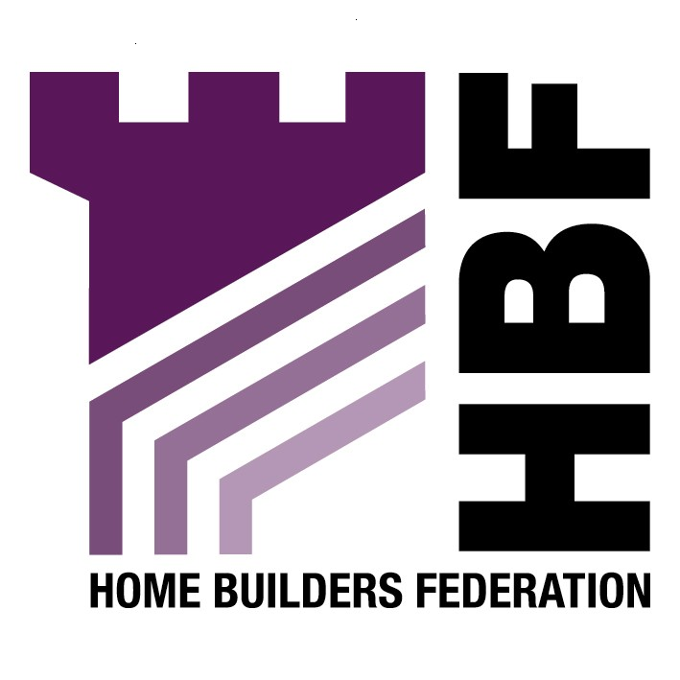

Emailed letter to ldf@leeds.gov.uk

Faxed to: 0113 247 6484

LDF Consultation (Aire Valley Leeds AAP)
Development Department
Leeds
City Council
Leonardo Building
2 Rossington Street
Leeds
LS2 8HD

23 May 2006

Dear Sir or Madam

Aire Valley Leeds (AVL) Area Action Plan - Alternative Options Consultation

Thank you for inviting the Home Builders Federation (HBF) to comment on the Aire Valley Leeds (AVL) Area Action Plan - Alternative Options. Please note the following comments in relation to questions in section 3 (questions 9 – 11) of the questionnaire.

Q9. Do you support mixed use development on the fringe of city centre which incorporates housing?

We are generally supportive of development of the fringe of Leeds city centre that incorporates housing development.

Q10. Do you consider there is need for a new ‘village’ or other large scale housing development in AVL? If yes, which locations are suitable?

While we are supportive of housing development on the fringe of the city centre in this area as confirmed above, we have concerns in relation to the term ‘village’ without robust evidence to support such a commitment.

The Knostrop Wastewater Treatment Works lies at the heart of the AVL and any development in this area would require major improvements at the Wastewater Treatment Works. Such works are estimated to cost in excess of £100million, which paragraph 2.13 of the AAP states would have to be financed from the enhanced land values of the new and more profitable forms of development. It is considered inappropriate and premature to identify locations for development when such significant infrastructure improvement requirements are undetermined and which may bring into question the viability of sites for development.

Q11. Overall, which housing options do you prefer?

Further to the comments above, we do not feel it is appropriate to limit the housing options solely to the two that have been suggested and would therefore have to state that the HBF could support neither option without further information to clarify the issues raised above.

It must be stated that our members would have serious concerns about the introduction of major new housing allocations that might be released ahead of existing commitments that are already allocated within and around the fringe of Leeds city centre.

HBF are concerned about the introduction of new housing allocations ahead of producing the Core Strategy Sustainability Appraisal which should be the vehicle by which to identify and test strategic development options. The method currently used by the City Council is ‘putting the cart before the horse’ and does not allow for the proper comparison of major sites across the District.

A Housing Market Assessment will be vital in the Area Action Plan process to provide robust evidence to support locations of major housing development. The preparation of a Housing Market Assessment should be carried out with the involvement of house builders beginning in the initial stages.

Thank you again for giving the HBF the opportunity to comment. We trust you will take our comments on board and look forward to receiving further information regarding the progress of the document.

Yours sincerely

Gina Bourne
Regional Planner – Northern Region

Home Builders Federation

