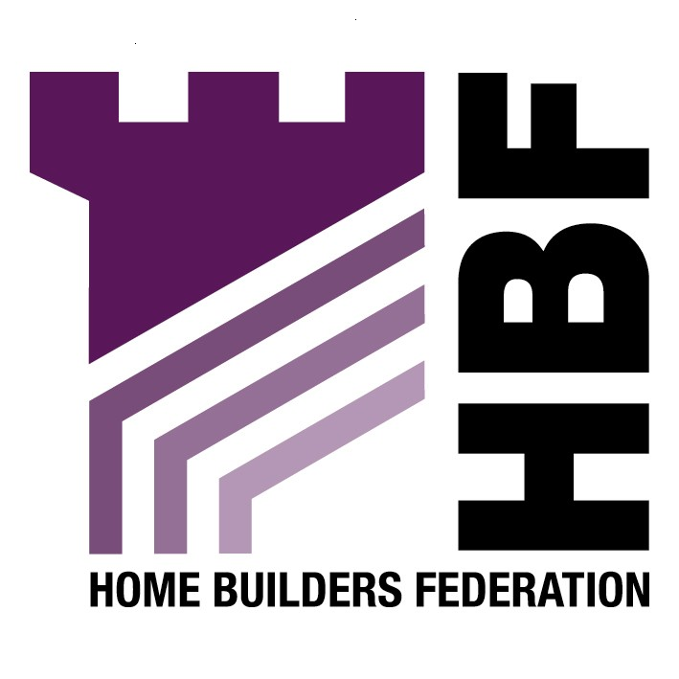

Stockton-on-Tees Borough Council

Local Development Framework

Core Strategy Issues & Options Consultation

Title & First Name | Miss Gina
Surname | Bourne
Organisation | Home Builders Federation
Address | Brooklands Court  Tunstall Road  Leeds
Postcode | LS11 5HL
Telephone | 0113 272 7573
Email | gina.bourne@hbf.co.uk

1. The Vision: Do you think that the Vision set out in paragraph 3.3 is a suitable base for the Core Strategy?

Yes.

2.a) Objectives: Do you agree with the themes and objectives suggested in Table 1 on page 9?

Yes.

2.b) Are there any other themes which should be included?

There is no theme relating to provision of housing. A theme should be included that represents the Government’s key objective for housing - to ensure that everyone has the opportunity of living in a decent home, which they can afford, in a community where they want to live.

4. Which of the options set out in section 6.5 will, in your opinion, best meet the development needs of the borough as a whole?

Option 2.
8. Should the Council? (Select 1 option)

B) Plan to achieve the target for housing development set out in the Regional Spatial Strategy, assuming that they do not vary significantly from the draft proposed figures.

Support of this option is dependent upon an up to date housing market assessment.

9. What approach should be adopted by the Core Strategy, in relation to the location of new housing development?

Given the emerging Government guidance set out in draft PPS3, HBF considers it ill-advised to proceed with the principle of a sequential approach in relation to development principles when that approach no longer forms part of emerging Government thinking. The sequential approach has been deliberately omitted from Draft PPS3 as a way of speeding up the delivery of and release of land for housing. Government acknowledges that the sequential approach has been mis-applied by many local authorities and has been used as a tool to avoid releasing sufficient land for housing rather than its intended purpose, which was to ensure that sufficient land was released but that those releases should be the most sustainable.

PPS3 still prioritises the use of previously developed land over greenfield, however this aspiration should be expressed in terms of the priority being given to previously developed sites, and should not be expressed using the terminology “sequential approach”, as that approach has a very precise and specific meaning, which is no longer appropriate.

The Core Strategy should adopt B) a more dispersed approach allowing the development of brownfield land within urban areas to be developed on a first come first served basis, but also the release of appropriate greenfield sites.

10. In developing an approach to cater for a range of households, should priority be given to: (Choose 1 option)

D) Allowing provision to be market driven (this option will rely on market forces/developers to dictate the type of living accommodation to be built within the area. The Authority will have no control over whose needs/aspirations are being met in terms of housing provision. Provision could be focused on one or two client groups, to maximise development profits).

Development of this approach should be in accordance with Government policy PPS3 and Northern Way Sustainable Communities Strategy.

17. How should the development needs of the rural villages be met? (Tick 1 option)

A combination of the following 2 options and will be village specific.

A) By continuing to allow small-scale infill development in rural villages.

B) By allowing small greenfield extensions to some of the larger villages, particularly those that are better served by public transport and local services and facilities

18. How should we go about meeting the needs of those who cannot afford to buy or rent in the private sector?

B) Set a lower threshold if appropriate to Stockton Borough’s particular needs.

19. What type of affordable housing should be provided?

D) A mixture of the above.

20. Should all new housing development be encouraged to adopt the “excellent” standard EcoHomes rating?

Yes ‘encouraged’ but not forced.

21. Should all new development be required to incorporate “Secured by Design” standards?

Yes.

23. The consultation paper on a new Planning Policy Statement 3: Housing, indicative density ranges (Dwellings Per Hectare) as shown on page 26 are suggested for new residential development: Are these ranges generally appropriate for Stockton Borough?

Yes in most areas.

26. Should priority be given to the retention of existing industrial estates for employment use?

No. Some existing employment sites should be considered for redevelopment for alternative uses, if it can be shown the land is no longer needed for employment uses. Alternative uses, such as residential development may be more appropriate in certain circumstances.

33.a) Should all new development contribute towards renewable energy targets?

No. Paragraph 1.8 of PPS12 makes it clear that planning policies should not seek to duplicate or cut across matters more appropriately within the scope of other legislative regimes. Energy efficiency in building use and construction is the responsibility of the building regulations Part L. The result of a recent review of these regulations is that all new homes built after April 2006 will be 40% more energy efficient than new homes built in 2002. That is a massive and extremely rapid improvement in performance and new homes are now many tens of times more energy efficient than the existing stock. There must come a point at which, if we are to make real efficiency gains, more attention is given to existing stock, rather than constantly going for the easy option of further restrictions on new building. These requirements are making new homes ever more expensive at a time when affordability is a serious concern and also at a time when these features are still not wanted by consumers.

34. Should all new buildings and conversions include energy efficiency measures, except where those measures would be harmful to the character, appearance or setting of a Listed Building or conservation area?

No, this issue should be considered on a site by site basis.

43. Should all new non-domestic developments (including new houses) contribute towards meeting the costs to the community that arise from them?

No, this issue should be considered on a site by site basis.

