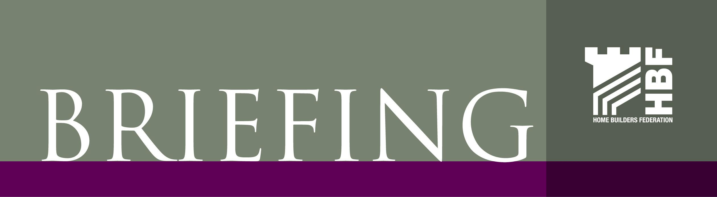

13 December 2006
Climate Change

The Government today published a challenging package of measures for the home building industry, which will help to reduce carbon emissions and bring innovation.
The Government is proposing that all new homes be zero carbon by 2016.
By this they mean that energy efficient and insulated buildings, using energy from zero or low carbon technologies, will produce no net carbon emissions from all energy use over the course of a year.
The overall strategy, as set out in the consultation document Building a Greener Future: Towards Zero Carbon Development was issued today as part of a package of wide-ranging measures, which includes:
a framework for progressively tightening building regulations up to 2016 to increase the energy efficiency and reduce the carbon footprint of new homes
the publication of the Code for Sustainable Homes, which sets out a star rating from one to six (with six being the most sustainable) which can be applied to all new homes.
a consultation on a Planning Policy Statement on climate change, which expects new development to be located to optimise its carbon performance.
The closing date for both the consultations is 8 March 2007 and the documents can be found on the DCLG website:

Building a Greener Future
http://www.communities.gov.uk/index.asp?id=1505157

Planning and Climate Change
http://www.communities.gov.uk/index.asp?id=1505140

The Code for Sustainable Homes is available at
http://www.planningportal.gov.uk/uploads/code_for_sust_homes.pdf

HBF will be reviewing the consultation documents and reporting back to members. We also wish to set up a working party to look at these issues and form an industry response to the consultations. If you would like to volunteer please email sian.lewis@hbf.co.uk.

D F Mitchell
Technical Director

