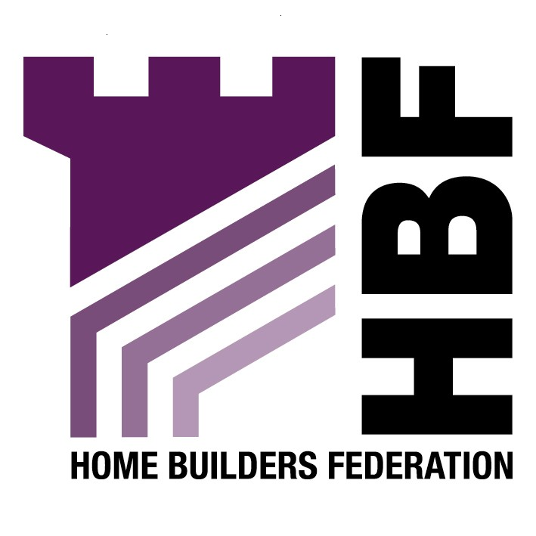

Emailed to forwardplanning@chester.gov.uk

Forward Planning
Chester City Council
The Forum
Chester
CH1 2HS

03 April 2007

Dear Sir or Madam

Draft Supplementary Planning Document Affordable Housing: Re- Consultation

Thank you for giving the Home Builders Federation (HBF) the opportunity to comment on your Draft Supplementary Planning Document for Affordable and
Housing within Chester. The HBF have considered the proposed document and have made the following observations:

Proposed Changes

The HBF welcomes the proposed changes to reflect national policy updates to the draft supplementary planning document, as it emphasises the need for policies to be based on up to date national policy guidance.

7.3

The HBF believes that setting smaller site size thresholds, in this case to 15 units or 0.5 hectares, would be unworkable in practice. It supports the Council’s recognition that the impact of the threshold on the economic viability, overall levels of housing delivery and creating mixed communities. It must be recognised that affordable housing requirements must not be so onerous that they threaten the delivery of the Council’s overall housing requirement. The Council has to consider a vital matter that, the very fact that thresholds are lowered is likely to reduce the supply of smaller sites coming to the market. Overall there is a need for flexibility, and HBF supports the use of a cascade approach to determining thresholds.

7.4

It supports the updating of the Housing Needs survey, so that the evidence base is credible. However, It is important to note that such assessments are now changing and the Government is to place increased emphasis on Housing Market Assessments. This must be undertaken to look at the need for all forms of housing (not just social rented) and be carried out in the appropriate manner in full consultation with local landowners, developers and other interested parties before any policy approach can be considered robust. The HBF considers it is important that policy is founded on the most up to date robust and credible evidence base.

The Federation does not consider it appropriate to delegate matters such as the amount, type and size of affordable housing to a SPD. Any matters of importance to development costs will instead need to be clearly set out in a Development Plan Document (DPD), rather than being delegated down to a SPD. Given that they could potentially have a significant impact on development viability, they must instead be dealt with in DPD’s and subjected to the appropriate public scrutiny bestowed upon these.

Thank you again for giving the HBF the opportunity to comment. We trust you will take our comments on board and look forward to receiving further information regarding the progress of the document.

Yours faithfully,

Laura Edwards

Laura Edwards (maternity cover for Gina Bourne)
Regional Planner – Northern Region

Home Builders Federation

