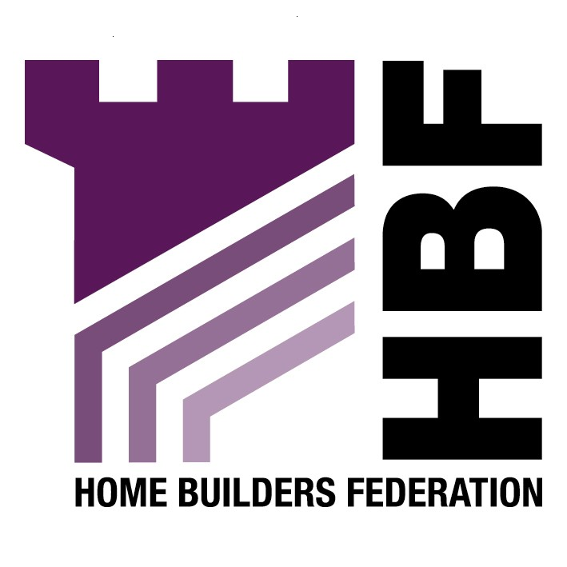

Emailed to spi@oldham.gov.uk

Strategic Planning and Information
Regeneration Directorate
Oldham MBC
PO Box 452
Oldham Business Centre
Cromwell Steet
Oldham
OL1 1WR

16 April 2007

Dear Sir or Madam

Oldham and Rochdale Raising Design Standards

Thank you for giving the Home Builders Federation (HBF) the opportunity to comment on your draft Urban Design Guide SPD. The HBF have considered the document and have made the following observations:

The Residential Design Guide

Section 5: Building Design

HBF support the flexible approach to density based on a number of criteria involving character assessment and accessibility to services, that this document proposes.

With regards to the guidance on “lifetime homes” there are a number of means of providing access and flexibility without specifically requiring lifetime homes. The option should require the provision of flexibility, without detailing the need for “lifetime homes.”

The recommendation that all new dwellings should meet the Eco Homes “Very Good” standard as a minimum is objected to by HBF. Achieving the Eco Homes very good standard adds a couple of thousand pounds to the costs of a home and achieving the excellent standard more than doubles this amount. Overall making housing even more expensive at a time when affordability is a serious concern. Paragraph 1.8 of PPS12 makes it clear that planning policies should not seek to duplicate or cut across matters more appropriately within the scope of other legislative regimes. Energy efficiency in building use and construction is manifestly the responsibility of the building regulations. There must come a point at which if we are able to make real efficiency gains, more attention is diverted to the real culprit, namely the existing stock, rather than constantly going for the easy option of further restrictions on new building. HBF notes that the Government requires standards should be set by the new Code for Sustainable Homes, which is replacing the Ecohome Standards.

Design and Planning Process

Design Process: Consultation

We believe that the expectation that applications for major developments and other developments of community significance will undertake pre- submission community involvement is too onerous, and we consider this could be more flexible. We feel it is important that the applicant has the flexibility to chose what sort of consultation exercise to undertake, that is best suited to reflect the scale and nature of the proposal.

Reference should be made to house builders/ developers/ landowners/ planning and estate agents being involved in the planning process, when determining who to consult.

Thank you again for giving the HBF the opportunity to comment. We trust you will take our comments into account and look forward to receiving further information regarding the progress of the document

Yours faithfully,

Laura Edwards

Laura Edwards (maternity cover for Gina Bourne)
Regional Planner – Northern Region

Home Builders Federation

