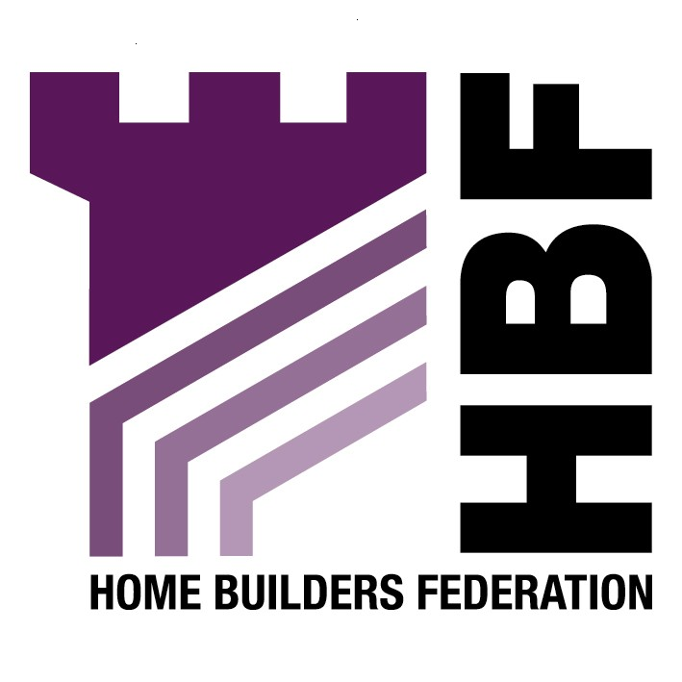

Emailed to forwardplanning@lancaster.gov.uk

Michelle Williams
Forward Planning Consultation Assistant
Planning Services
Lancaster City Council

02 April 2007

Dear Madam

Supplementary Planning Document: Design Issues and Options

Section 3: Issues

Energy Efficiency

The Home Builders Federation and Britain’s home building industry is working together with the Government to start addressing how to deliver the Government’s ambitious attempt to deliver higher environmental standards.

The home building industry broadly welcomes the Government’s environmental targets. However, home builders cannot achieve them alone. HBF and other parties have begun the crucial task of working out how we can achieve higher environmental standards and at the same time deliver the step-change in housing output that the country so badly needs. The house building industry has set itself the challenge for all new homes to be zero carbon within 10 years.

The HBF does not support the inclusion of the 10% Merton Rule, as its implementation has proven to be unworkable, and this might not be the most appropriate means of achieving an overall emissions reduction, either technically or financially.

Option 3.5i is believed to be the most viable option presented as the draft PPS: Planning and Climate Change (supplement to PPS1) paragraph 31 states ‘planning authorities should not need to devise their own standards for the environmental performance of individual buildings as these are set out nationally through the Building Regulations. Higher standards for new homes are set out in the Code for Sustainable Homes. Where planning authorities wish to require higher levels of building performance, because of local development or site specific opportunities, the expected local approach should be set out in advance in a development plan document. For new homes, local standards should be based on the Code for Sustainable Homes’.

In accordance with the above advice, the HBF considers that the issues included in this draft SPD should not be presented and considered simply as a Supplementary Planning Document. Such policies could potentially have a considerable impact on developments and their viability. These requirements are making new homes even more expensive at a time when affordability is a very serious concern. Therefore, this policy approach should be worded flexibly in recognition of these concerns. There should not be hard and fast requirements for achieving non-statutory and unenforceable criteria.

Thank you again for giving the HBF the opportunity to comment. We trust you will take our comments on board and look forward to receiving further information regarding the progress of the document.

Yours sincerely,

Laura Edwards

Laura Edwards (maternity cover for Gina Bourne)
Regional Planner – Northern Region
Home Builders Federation

