

Vicky Fletcher
Land Management Planner
Landscape Planning and Heritage Group
Environment Department
Hampshire County Council BY EMAIL ONLY
The Castle
Winchester
Hants. SO23 8UD
1st June 2007
Dear Vicky,

SOUTH HAMPSHIRE GREEN INFRASTRUCTURE STRATEGY

I refer to your email of 31st May and attachment regarding the above. Firstly, many thanks for seeking our involvement in this work at this early stage. Having flicked through the document I'm not quite clear what is required of us at this stage. But, there are a couple of points which spring to mind.

Firstly, what is set out in the report says very little about what local authorities themselves can do to improve the existing resource so that it can be used more efficiently and effectively to fulfil the role of proper green infrastructure. Instead the report seems to be a precursor to developing a wishlist of new schemes from which developers contributions will be sought. The biggest green infrastructure asset is the green infrastructure which already exists and the scoping should assess what exists and what needs to be done to improve it for the needs of the existing population out of the public purse rather than just (or mainly) looking to provide new facilities for the occupiers of new development via developer contributions. This should be a key part of the opportunities for improving the green infrastructure resource which is not currently mentioned.

Clearly developer contributions will be an important part of improving the existing green infrastructure asset but my reading of the workshop feedback report is that, not surprisingly given who attended workshop, it is looking a where new funding and provision can be sought from developers rather than focussing equally on what local authorities themselves could do with existing powers and funding as part of a co-ordinated strategy of improvements. I would have thought that, at this stage, the exercise should be considering these broader strategic concepts rather than simply restricting itself to what can be secured from new development.

Having said that, the key issue for developers and landowners boils down to the detail. What do the local authorities want and what is it going to cost ? It is Appendix 2 which is likely to be of most interest. But this should be expanded as the project evolves to say why what is being sought is being sought, how it relates to new development proposed in South Hampshire, what it will cost to deliver the improved or new facilities, what public funding there will be into the project (as stated above, it cannot be expected that all of this programme should be paid for from new development) and so on. Once we have this worked up it will be much easier to get house builders interested. At this stage I doubt whether there would be much interest from developers in getting involved in this process though I am happy to attend the workshop on the 19th July. I will circulate your email and the attachment along with this letter to my Members who I know have interests in South Hampshire and if there is more interest in attending the 19th July seminar I will let you know.

Secondly, in terms of issues for growing the GI resource various process things are mentioned like implementation, cross-boundary working and so on. The key things from the landowner / developers' perspectives would be clarity and transparency in that whatever is required should be clear, explained, justified and costed and made known early in the formulation of plans for development. This is particularly the case with the larger developments planned for South Hants over the coming years. It is vital that what emerges from this study, if it is to be delivered, forms part of the formal planning framework and is widely circulated and consulted upon in order that those currently drawing up proposals for new development and undertaking negotiations on deals with landowners can be aware of the authorities' requirements. A separate non-statutory informal green infrastructure strategy introduced at some late date is not particularly helpful to developers. Instead, whatever is required should be set out as part of the local development framework, preferably as part of a development plan document, in order that everyone is aware of what is required and that it can be subject to testing through the statutory procedures.

Finally, when it comes to costings, it should be borne in mind that there are a multiplicity of demands on funding from new development for everything from affordable housing, education, roads, social and community infrastructure, on-site energy production and so on. If it exists, there is a local authority somewhere who has sought to get funding from a developer to deliver it ! There is only a finite pot of funding available from new development which means that there may need to be prioritisation of policy objectives by local authorities. Sight should not be lost of this fact when the later versions of the strategy are being drawn up.

I hope these are helpful as initial comments but if there is anything else I can help with prior to the 19th July please let me know.

Yours sincerely,
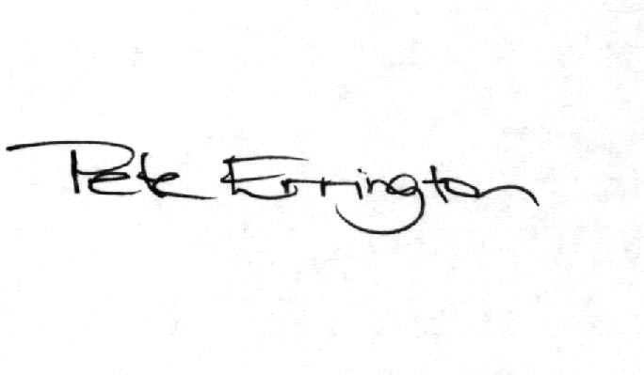

Pete Errington
Home Builders Federation
Regional Policy Manager (South, East & London)

