

Eleanor Fielder

Policy Planner BY EMAIL ONLY

Havant Borough Council

Civic Offices

Havant

PO9 2AX

6th June 2007

Dear Mrs Fielder,

HAVANT BOROUGH COUNCIL LOCAL DEVELOPMENT FRAMEWORK

STRATEGIC HOUSING LAND AVAILABILITY ASSESSMENT

Thank you for consulting the Home Builders Federation (HBF) on your draft methodology for the above study. Apologies for the very slight over-running your deadline for comments. I hope that there will still be the opportunity for the comments below to be taken on board.

HBF is pleased at the early engagement with stakeholders on this study. However, having said that, HBF also has a number of serious concerns about the study. Mainly in that it is neither one thing nor another. It is neither a housing land availability assessment (HLAA) nor a housing market assessment (HMA) yet PPS3 is clear that it is HLAAs and HMA which should comprise the evidence base in support of policies and proposals in Development Plan Documents, There is no scope, under current Government guidance, for housing or urban capacity studies to inform the decision making process. Despite the HLAA title, what this draft methodology suggests is being proposed is merely an updating of the existing urban capacity study; not a housing land availability assessment as required under PPS3. All the comments set out below follow from this fundamental point that we do not believe the council should be carrying out a UCS and that we do not consider the draft methodology to be anything more than an updating of the current UCS.

Firstly, HBF welcomes the fact that the assessment is to look at all areas of the borough rather than just focussing on priority areas. We also welcome the fact that the study proposes to look in detail at Leigh Park rather than relying on past rates. Generally, however, the remainder of the methodology is an old-style urban capacity study methodology and not a housing land availability study methodology.

Secondly, turning to the methodology itself the approach to evidencing the policy base clearly set out in PPS3 means that the assessment should only be dealing with sites which are deliverable. The sites and the numbers attributed to them should be realistic and achievable. There is no scope in under PPS3 to deal with theoretical or unconstrained capacity or arbitrary or discounted yields. The capacity identified in the study should be all of the “….ables” set out at paragraph 54 of PPS3 and the methodology should make clear how it will arrive at decisions about availability, deliverability and achievability of the development opportunities put forward. The methodology as it stands hardly touches on these vital aspects at all.

Thirdly, dealing with the sources of supply, HBF would remind the council that the approach should set out to identify as much potential capacity as possible. PPS3 is clear (and it has subsequently been further clarified in a recent CLG statement to local and regional planning authorities) that windfalls should not be included in housing trajectories other than in exceptional local circumstances (paragraph 59). Exceptional local circumstances does not mean that, just because the council has always counted windfalls in previous urban capacity studies under PPG3, this can continue. That is not an exceptional local circumstance as all authorities have, in the past, included windfall allowances. Exceptional local circumstances relate to the nature of the sites likely to come forward. Hence the need to identify as much of the potential supply as possible.

Therefore, while it is perfectly acceptable for the assessment to address the issue of windfalls, PPS3 is clear that they cannot be included in housing trajectories and assessments of land supply. This must be made clear in the methodology and the presentation of the final results.

Fourthly, and following on from the above, it is HBF’s view that the draft methodology is very weak in explaining how it will factor in developability and market considerations into the methodology. This is a major concern to HBF. The report simply refers to the fact that these aspects will be considered. It says nothing about what the council or the assessors will actually do or take into account in assessing developability other than testing a small sample of sites against a development costs spreadsheet.

Given that this is the proposed methodology (rather than, say, just a scoping report) this is a very major omission. The methodology gives no real detail on how it will take on board the views of house builders, landowners or estate agents about whether the types of sites identified are the types of sites they are interested in bringing forward or on which there is likely to be a demand to live. It says nothing about taking on board the views of the likely purchasers of new housing in the borough. It says nothing in any detail about the costs associated with bringing forward sites for development. It says nothing about alternative use values. It says nothing about the costs imposed on new development by local authorities in the form of affordable housing and other planning obligation and infrastructure requirements, tariffs, taxes and so on. Whilst affordable housing is mentioned briefly, other planning obligations are not. All of these considerations have a major impact on whether a site is likely to be deliverable.

The final methodology must spell out very clearly how, what, why, when and who will be involved in factoring in these vitally important considerations. If it does not, the assessment will not be fit for purpose. It will not, therefore, comprise robust evidence which can be used to demonstrate the soundness of any policy approach or allocation from which it is derived. Similarly, with regard to deciding when sites will be likely to come forward for development, it is not for the council or its consultants to unilaterally determine this. The HLAA approach requires the full and proper co-operation of local house builders and developers in reaching a view about the future housing trajectory and the methodology should set out the mechanisms and processes by which this will be achieved.

I hope these important matters can be taken on board prior to the council fully embarking on this work. Given the serious flaws in the proposed approach HBF would advise that the council postponed work on this study and, instead, carried out a proper housing land availability assessment as required under PPS3 based on the guidance which will be published in only a couple of months time. That is certainly the case if it wishes to avoid abortive work and incurring unnecessary costs.

Yours sincerely,
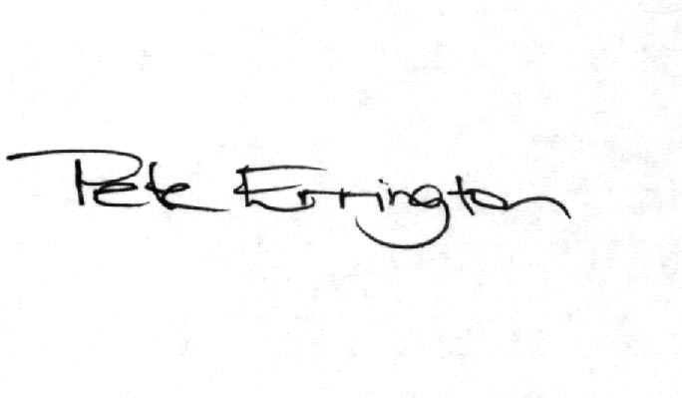

Pete Errington
Home Builders Federation
Regional Policy Manager (South, East & London)

