

Graham Loveland
Assistant Director (Planning)
Islington Council
PO Box 3333

Municipal Offices
222 Upper Street

London N1 1YA

BY EMAIL ONLY
8th August 2007
Dear Sir,

ISLINGTON’S CORE STRATEGY

I refer to your letter of 30th July to my erstwhile colleague Jonathan Sheldon regarding the above which has just been forwarded on to me.

The Home Builders Federation wishes to express the utmost concern at the content of the letter. Particularly in so far as the proposed adoption as non statutory advice of what is clearly a fundamentally flawed and unsound policy document is concerned.

If the core strategy has had to be withdrawn due to fundamental failings with its content and/or the evidence under-pinning it then it makes a mockery of the planning process for the council to go on and then adopt that withdrawn document as non-statutory advice. Had the advice been fit for purpose the core strategy would not have been withdrawn and there would be no need for informal advice. The fact it has been withdrawn because it is not fit for purpose as statutory policy means that it is equally unfit as non-statutory, informal policy advice. Adopting unsound and flawed policy as non-statutory informal policy advice (which will no doubt continue to be applied by the council as if it had the weight of a submitted core strategy) is totally unacceptable

For the avoidance of doubt, the so-called advice note comprising the withdrawn core strategy does not carry the weight of a submitted core strategy. Merely advising stakeholders of the withdrawal of the core strategy and its adoption as informal advice is so clearly contrary to Government policy that it does not afford that informal advice any legitimacy or credibility. Nor does it provide it with any weight as a material planning consideration in the day to day determination of planning applications.

The council should withdraw this policy advice and the policies and proposals it contains must not be applied to development proposals until such a time as the council has overcome the soundness concerns surrounding the submitted core strategy and until that strategy has been tested through the examination process and ultimately been adopted.

Yours faithfully,
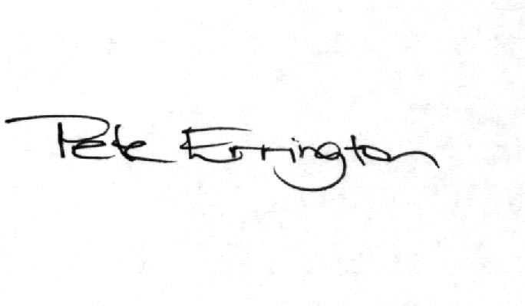

Pete Errington
Home Builders Federation
Regional Policy Manager (South, East & London)

