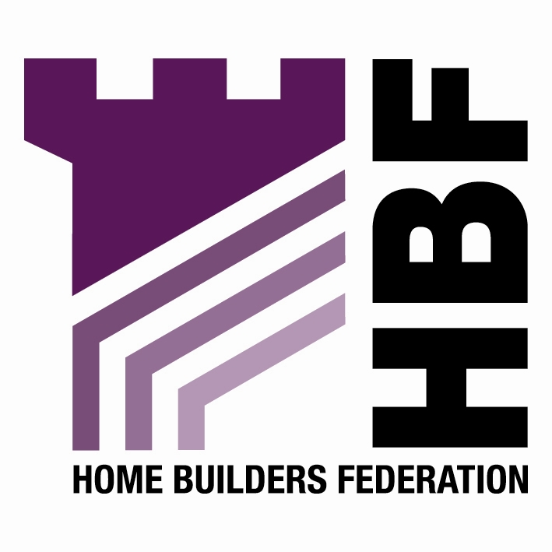

BY EMAIL ONLY

Forward Plans Group
AVDC
FREEPOST (11939)
66 High Street
Aylesbury
Bucks HP20 1ZA

30th August 2007

Dear Sir / Madam,

AYLESBURY VALE CORE STRATEGY DPD – PREFERRED OPTIONS

Thank you for consulting the Home Builders Federation (HBF) on your council’s core strategy preferred options. HBF has a number of comments to make which can hopefully be reflected in the submitted version of the document next year.

Vision & Objectives

For an authority that claims to be aspiring to be a vibrant and exciting place, it is a shame this excitement is not reflected in this consultation document. It is tedious and bland to say the least in terms of its style, content and presentation. A bit of colour, a few photographs or diagrams and better distinction between what is policy, what is explanation and what is technical justification will help engender a feeling of excitement and vibrancy in the reader. Obviously I acknowledge that his is just a preferred options stage but hopefully this matter can be addressed in the final submitted document

There is also a lack of enthusiasm and clarity in respect of the vision. I saw at least three visions set out at paragraphs 5.2.1, 5.2.4 and 6.2.1. The first of these at paragraph 5.2.1 is hardly an exciting or aspirational vision. It merely says that Aylesbury does not want to see itself listed in the series of books “Crap Towns” (unless it already has been !!). If this is the vision of any council strategy then it does not bode well.

The other two visions are a bit better, but not much.

The vision should not be a bland statement of aspiration. It should relate specifically to Aylesbury rather than be an ‘anytown’ vision. More importantly it should relate to the core strategy objectives.
In this instance it should be about delivering growth in a sustainable way to create a vibrant and attractive town to the benefit of existing and future communities. At the very least, there should be a single vision and it should be made clear what that vision is.

Finally on presentation, and in terms of this being a not particularly inspiring document, there are 25 pages of tedious background information before the reader even gets to the nitty-gritty of the core strategy itself. This introductory and background text should be removed from the document and placed in some sort of annex so that the reader can feel excited and encouraged to read more by starting with the vision. Either that or it should be radically truncated so as not to detract from the main purpose of the document which is to set out the core strategy itself.

Evidence Base

While it is accepted that this evidence base is an evolving creature HBF will expect the submitted core strategy to be informed by the results of a housing market assessment rather than a housing needs study (and it is noted from later in the document that this is underway) and a strategic housing land availability assessment rather than a urban capacity study. There is no reference in the document to a SHLAA but the strategy will not ultimately be found to be sound if its housing provisions are not based on robust and credible evidence in the form of a SHLAA. Obviously HBF and its Members would be very keen to be involved in the preparation of such a document along with the HMA in accordance with the guidance set out in PPS3 and the accompanying practice guidance notes.

CS1 – Sustainable Development & Design

As is the nature of the preferred options stage, it is difficult for stakeholders to comment on the individual policy areas in any detail due to the lack of any specific policy wording in the document. However, it has to be said that what is set out just appears to be a reiteration of national policy. There is nothing in the text which relates this to the unique needs and characteristics of delivering major growth in Aylesbury district. The final version of this policy must be much more geographically specific than is suggested by the preferred options text if it is to be found sound.

CS3 – Growth of Aylesbury

Firstly a minor comment in respect of paragraph 6.7.1 – there is no table 2 on page 11. I think you mean page 14.

More substantially, however, HBF is extremely concerned to read that there were only 290 completions recorded in the year 2006-7 at a time when the annualised requirement is for 840 (or almost 880 taking into account past under-supply). It is clear from Table 3 on page 41 that there has long been under-delivery in Aylesbury and this suggests that the past under-supply is still not adequately being addressed. This is extremely worrying.
It is also something which must be explained and addressed in the submitted document. Simply recording this fact is not sufficient. The final strategy must set out the reason why this has occurred, what action will be taken to address it and what contingencies will be in place in case those actions are not successful. Delivery, delivery, delivery is the Government’s current housing mantra and this document must set out how it will ensure it plays its part, particularly in view of the importance of Aylesbury’s role in respect of its relationship with Milton Keynes and the wider South Midlands growth area.

CS5 – Infrastructure Provision

There should be a reference in this policy to financial viability and the need to ensure that planning obligations sought do not prevent or delay development coming forward. In considering viability this should involve an assessment of infrastructure requirements and planning obligations in the round including affordable housing in order that the overall impact on development can be ascertained.

Policy CS9 – Affordable Housing

This policy must be informed by evidence from am HMA carried out in the proper manner in order to set a reasonable percentage target and site size threshold (or series of targets / thresholds). The policy wording must included reference to financial viability of development sites.

While the principle of supporting SPD is not objected to, there must be sufficient detail in the core strategy policy itself (including the percentage target and site size threshold) in order that the implications of these on housing delivery and the evidence under-pinning them can be properly tested at examination.

I trust that these comments will be taken on board and I would be pleased to be kept informed of progress on the preparation of the core strategy and associated DPDs as they emerge.

Yours faithfully,

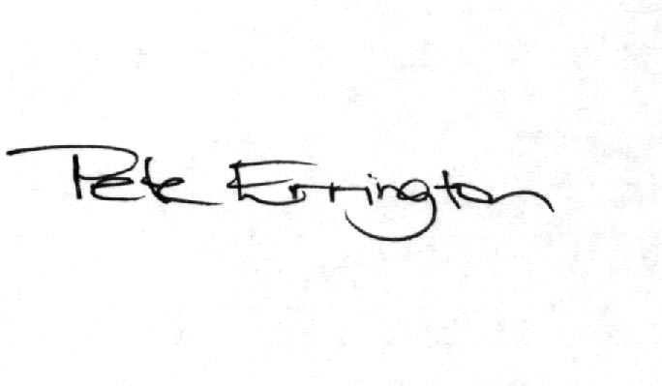

Pete Errington
Home Builders Federation
Regional Policy Manager (South, East & London)

