

BY EMAIL ONLY

Wendy Perera
Acting Planning Policy Manager
Planning Services
Isle of Wight Council
Seaclose Offices
Fairlee Road
Newport
Isle of Wight PO30 2QS

17th August 2007

Dear Mrs Perera,

ISLE OF WIGHT STRATEGIC HOUSING LAND AVAILABILITY ASSESSMENT

Thank you for allowing the Home Builders Federation (HBF) the opportunity to comment on this draft methodology.

Unfortunately I have to say that our comments are essentially negative. The main reason for this is that, since the council decided to embark on this work, Government has produced its final version of the PPS3 Good Practice Guidance (GPG) on carrying out Strategic Housing Land Availability Assessments (SHLAA). This supercedes the previous drafts and introduces important new aspects which are not adequately addressed by the council’s draft methodology. Moreover, Government strongly recommends (para 15 of the GPG) that the methodology prescribed in the GPG is followed in order to ensure that the findings are robust and transparently prepared.

Obviously the council could only go on the guidance as was available at the time so it could be argued that it is wrong for HBF to criticise the council’s actions. However, looking at this proposed methodology it is HBF’s view that the council has not even fully reflected the draft guidance which was available at the time. The council’s proposed methodology is little more than a traditional urban capacity study albeit that it extends to look at all sites rather than just brownfield. But, it fails to incorporate any of the basic requirements for carrying out a SHLAA.

The fundamental point HBF wishes to make, therefore is that, now the finalised GPG is available, the current draft methodology should be abandoned and replaced by an approach which complies with the new guidance prior to work commencing on the study. It is not just a case of modifying the existing approach. Unfortunately, it is a case of starting again with a new methodology based on the GPG.

The key change with the new GPG, and the fundamental failing of the draft methodology as it stands, is that the main thrust of the new approach is on assessing the deliverability of sites which is something the council’s draft methodology explicitly does not set out to do (paragraph 1.2 of the draft methodology). Both PPS3 itself and the GPG are clear that the emphasis of planning policy for housing should be on delivery. A SHLAA must therefore, if it is to be fit for purpose, consider the developability of sites and must address all of the “ables” set out in PPS3 (paras 54 and 56). Namely it must assess developability, deliverability, suitability, availability and achievability. This is identified in Figure 1 of the GPG as a core output of a SHLAA.

As the GPG sets out at paragraph 6, the primary role of the SHLAA is to identify sites with the potential for housing, assess (and so quantify) that housing potential and assess when that potential is likely to be delivered. In order to do this the council will have to continue to engage with key stakeholders such as house builders, landowners, developers, and estate agents in order to ensure that all relevant considerations are factored into assumptions about the PPS3 “ables” and so the assessment is robust and credible which obviously it must be to ensure that any policy derived from evidence contained in the SHLAA is sound.

The only other comment we wish to make is in respect of windfalls. Clearly while it is reasonable for the council to consider the issue of windfall development in the SHLAA, PPS3 and the subsequent clarification note on “Demonstrating a five year supply of deliverable sites” issued by CLG make it absolutely clear that no allowance for windfalls should be made in estimates of five (and ten) years supply other than in very exceptional circumstances. This relationship between the treatment of windfalls in the SHLAA and how this subsequently informs the housing trajectory and five and ten year supply calculations must be explained in the methodology.

Most importantly. it must not be assumed that, just because local authorities in Hampshire have always counted windfalls in their land supply calculations, this can continue under the new PPS3 regime. Under the new guidance local authorities including windfall allowances must fully justify why they have done this, not in terms of past practice or performance, but in terms of why it is not possible for them to identify sufficient sites to make up five (and ten) years supply. In other words, councils must explain why they cannot identify what would otherwise, if it remained unidentified, have come forward as windfalls (para 59 of PPS3).

It is unfortunate that the council has gone to the trouble of producing this draft methodology only to have much of that work negated by the new GPG. But, this was a possibility that was acknowledged at the end of the draft methodology. As stated above, however, in view of the extent of the discrepancy between the proposed methodology and Government’s preferred new approach set out in the GPG, it is a case of starting again from basic principles rather than merely updating or amending the draft methodology.

I trust that these comments will be taken on board and I would be pleased to be kept informed of progress on this study as it evolves.

Yours sincerely,

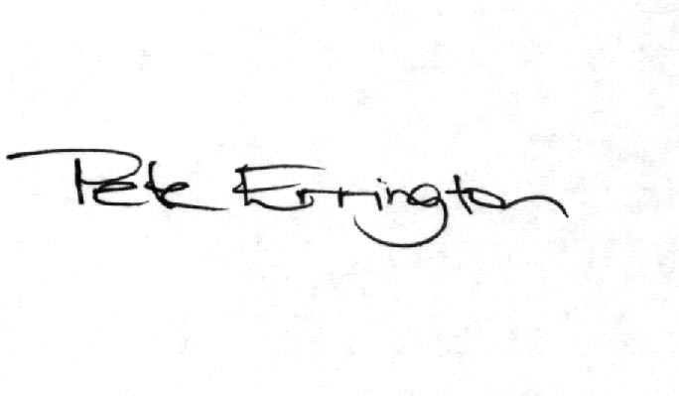

Pete Errington
Home Builders Federation
Regional Policy Manager (South, East & London)

